

Project Report

|  |  |
| --- | --- |
| e-Project Details | |
| Project Type | HTML5 Website |
| Project Title | HairCare |
| Student Details | |
| Student ID | Student Name |
| STUDENT1306302 | AMAAN AL MIR |
| STUDENT1307363 | MOHAMMAD AYYOUB KADKHODAEI |
| STUDENT1305541 | HAMZA FATTALL YABROODE |
| STUDENT1305954 | ABDULLA FUAD S. A. AL-MAHMOUD |

Acknowledgement

We would like to show our gratitude to **Mr. Jaspal Singh** for giving us good guidelines for the project throughout numerous consultations. Without your suggestions and assistance we would have not been able to complete this project.

We are also thankful to the Aptech Faculty Management for encouraging us in the execution of this project.

Many people, especially our classmates and team members, have made valuable comment and suggestions on this project which gave us inspiration to improve our project. We would also like to expand our deepest gratitude to those who have directly and indirectly guided us in the making of this project.

INDEX

Project Synopsis 3

Project Analysis 4

Requirement Specification: 4

Project Design 6

Site Map 8

User Guide 9

1. Navigation Bar 9

2. Footer 9

3. Homepage 10

4. Gallery 13

5. Products 17

6. Services 21

I. Treatments 21

II. Equipments 26

7. About Us 28

8. Contact Us 30

Developer’s Guide 32

Source Code 33

I. HTML 33

II. CSS 101

III. JavaScript 120

Project Synopsis

HairCare is an informational HTML5-based website on how to give a proper care for your hair for women.

The Objective of this program is to give a sample project to work on real life projects. These applications help you build a larger more robust application.

Project Analysis

Hair is probably one of the first things you notice about people when meeting them for the first time. This is especially true for women. Beautiful and shiny hair always leaves good impression, which is why proper hair care is important. Also, good care of your hair plays an important part in having healthy hair and helps avoid extensive damage that can lead to **hair loss**. Regular washing with celebrity advertised shampoos and conditioners is not enough. To have a healthy, strong and shiny hair, you need to know how to care for it daily.

Since the field is really vast, a need is felt that there should be a single platform which will give the complete information of haircare

Requirement Specification:

The Web site is to be created based on the following requirements.

1. Homepage with suitable logo and images, making use of sections.
2. Categorized menu which will include various categories as type of treatments available for various different hair problems like
   1. Hair loss
   2. Graying
   3. Growth related
   4. Premature baldness etc
3. The site should also include the various easy home remedies that can be helpful in dealing with various hair related issues.
4. There should be a section which will provide the details of hair care equipments like
   1. Dryers
   2. Straightners
   3. Spray bottles
   4. Steamers
   5. Massagers
   6. Spa caps
5. There should also be a section for hair care products as
   1. Hair cream
   2. Shampoo
   3. Conditioners
   4. Masks
   5. Serums
   6. Hairsprays
   7. Various hair oils
6. Along with the various equipments, there should also be user manual/guidelines for ease of its use and maintenance.
7. The site should also include the details as of which companies provide which equipments
8. Comparison among the same equipment of different companies should be possible based on availability, cost major features
9. Gallery section should include most common instruments along with their necessary details.
10. There should be a section which will enable user to know latest developments in the field
11. Contact us page: contact us details with location should be displayed using GeoLocation API (eg. GoogleMaps).
12. Navigation needs to be smoother.
13. The look and feel of the project must be made user friendly and uniformity in the color combination must be maintained.

Project Design

HairCare website is based on a simple and basic, yet attractive design, and used web standards.

The site consists a total of seven pages; five main pages and two subpages.

These pages mainly consists of header, main body, and footer.

The header displays a navigation bar that has a logo with the brand/company name and links to other pages on the right.



The footer also consists of the logo and the brand/company name with social media links and icons.



Furthermore, the website consists of several hyperlinks attached to specific areas of web pages which can be used to switch between pages easily.

Site Map

User Guide

1. Navigation Bar

Use the navigation/menu bar to navigation through different pages.



1. Footer

Click on the icons to visit their respective social media sites.



1. Homepage

The top of section of the homepage displays some important facts about the company.

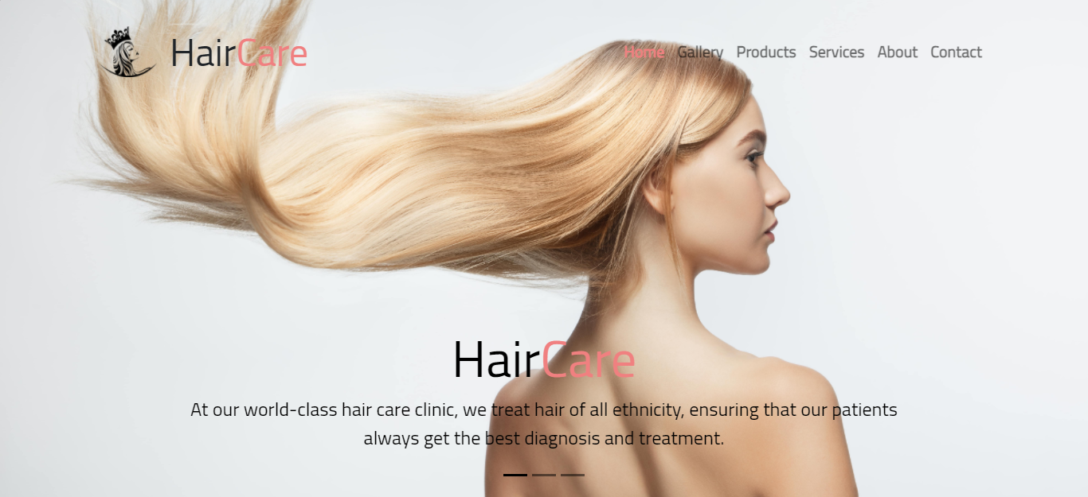

The section automatically slides throught multiple images to show you different facts. The user can also click on the indication on the bottom, below the text, to switch between the images.



The top section of the homepage, below the hero section, introduces the company and its purpose and what is there to offer the users.

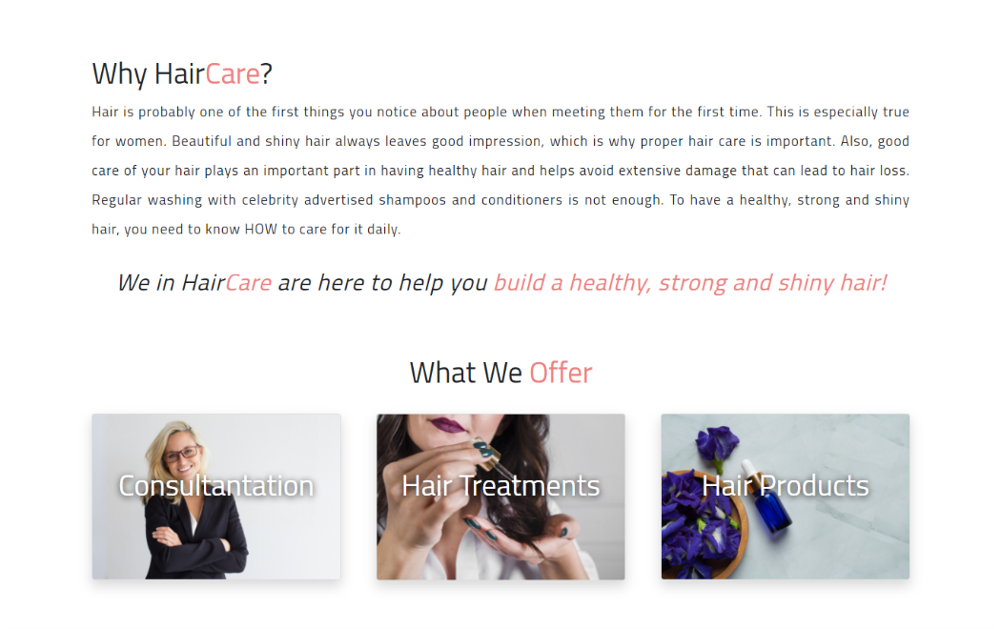

Then you’ll find a featured section with that links to different pages. 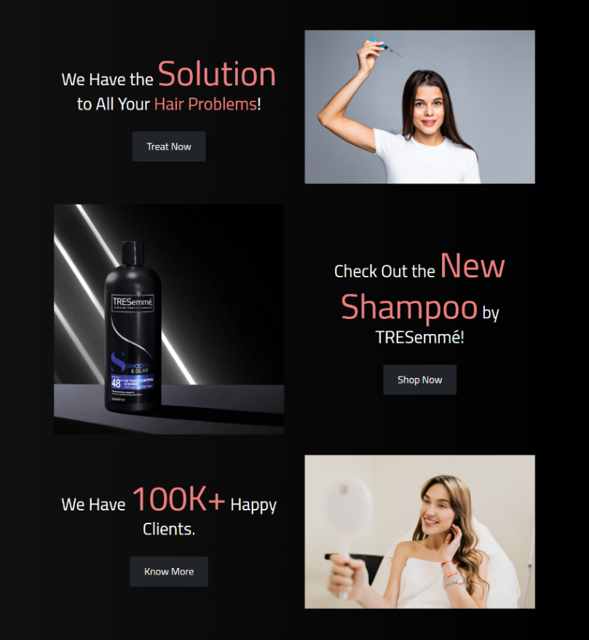

The homepage also provides a button that will redirect users to the Gallery page.



And at the end, it features a hastag used online to refer to the company.



That was the end of the homepage.

1. Gallery

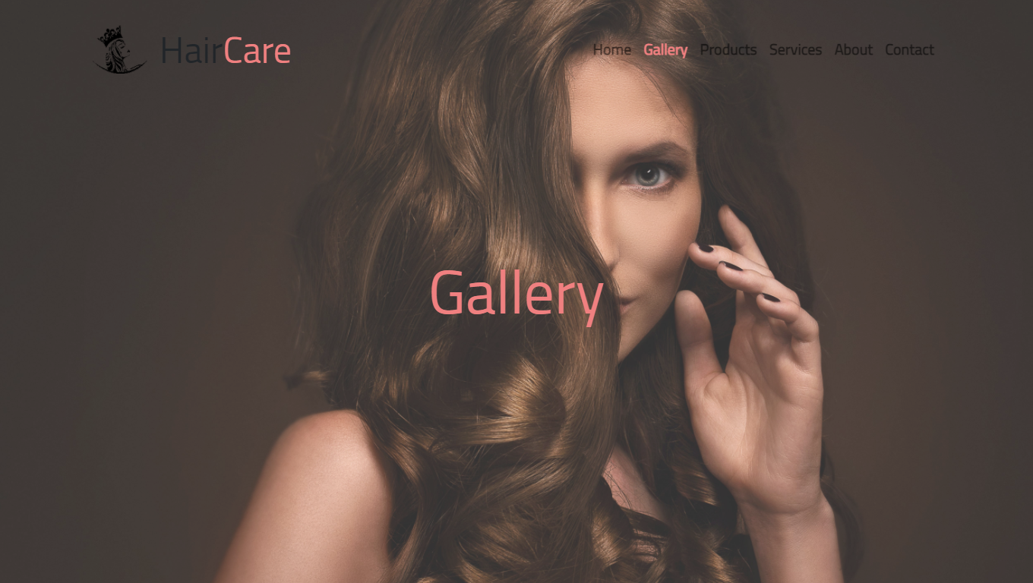

The gallery displays various photos of our clients and customers and also some of the product collection we have from our most trusted brands.

It also display the company’s social media tag.



Photos of our clients and customers.

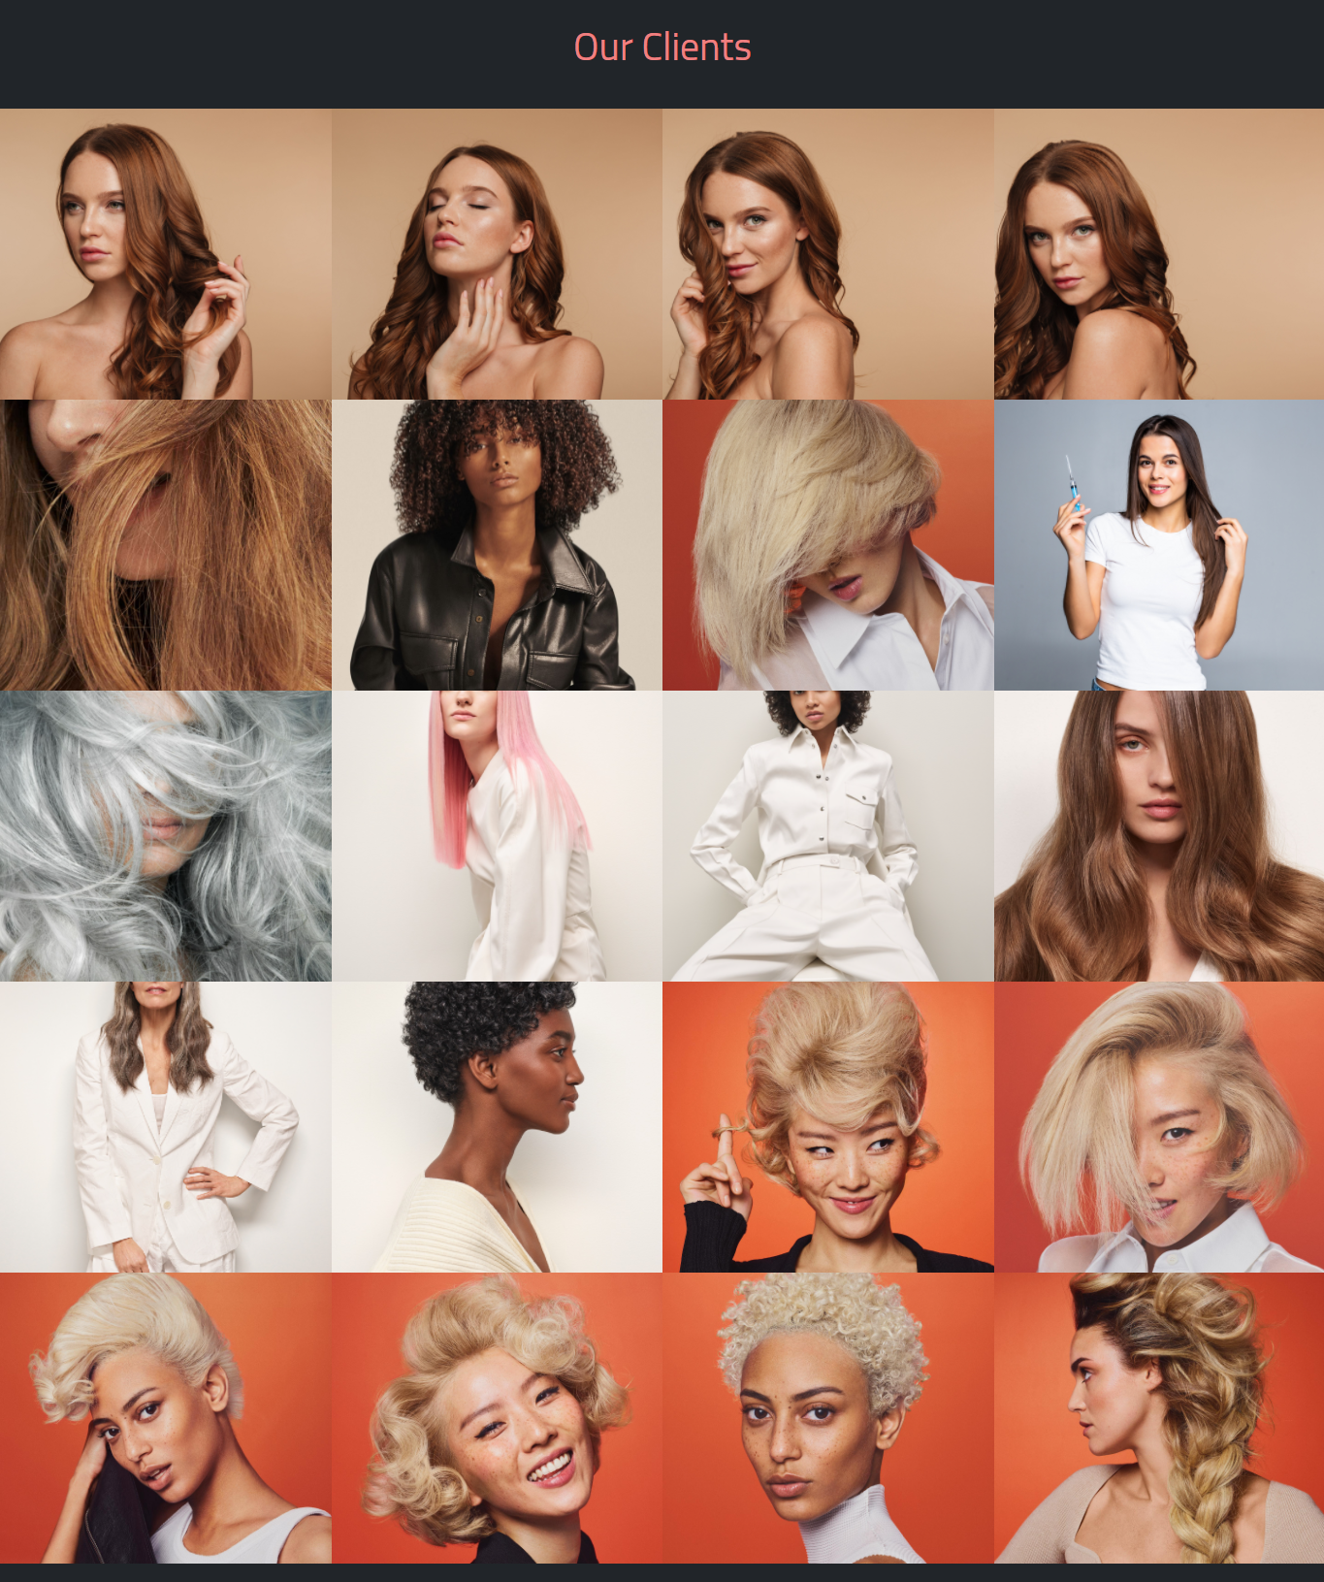

Some of our product collections.

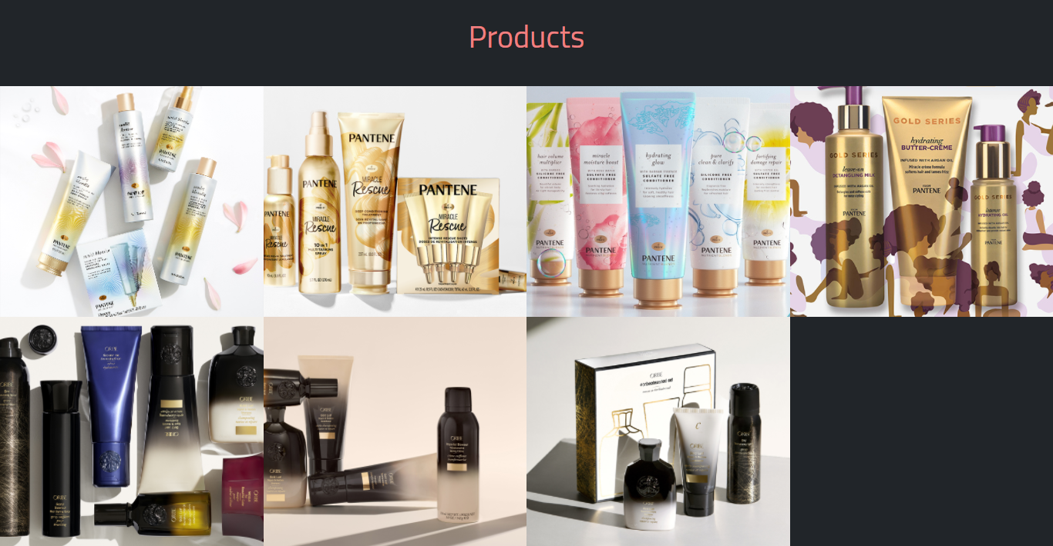

Click on an image to enlarge it.



Hover (place your cursor) on an image to get a brief information about it.



You can also browse through the images without closing the modal just by clicking on the previous or next button.



That was the end of the gallery.

1. Products

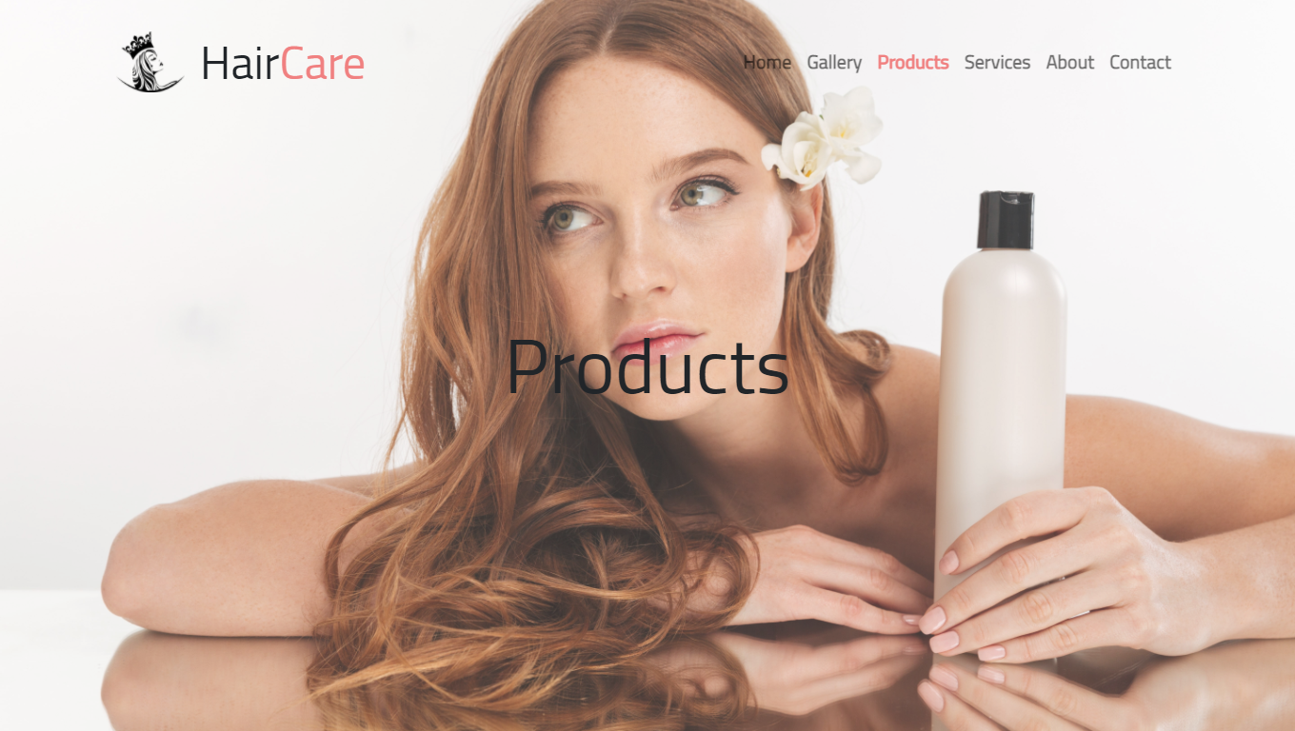

A little introduction about the products we recommend and how you can get them.

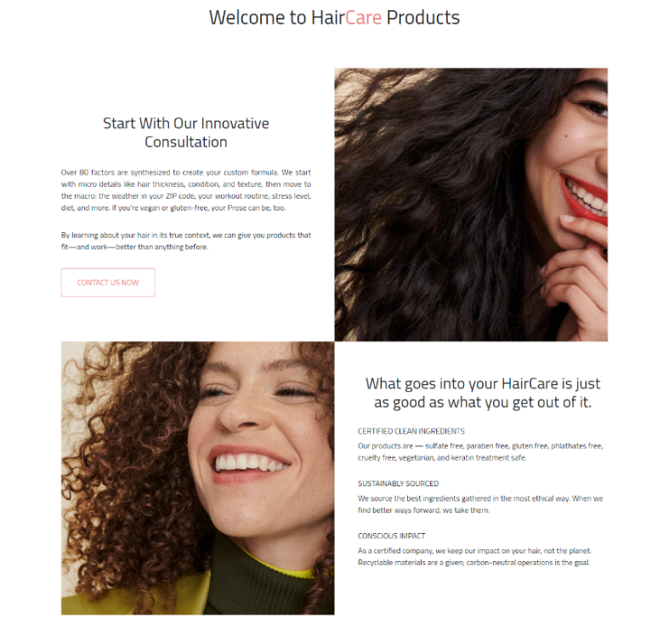

Some of our most trusted brands.

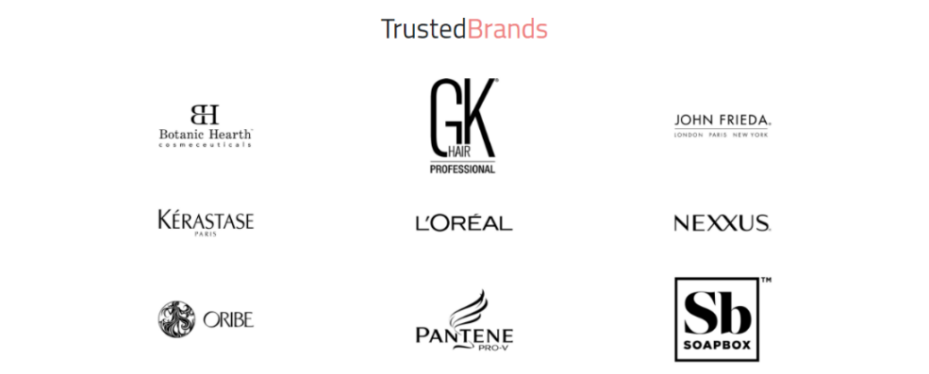

List of Products

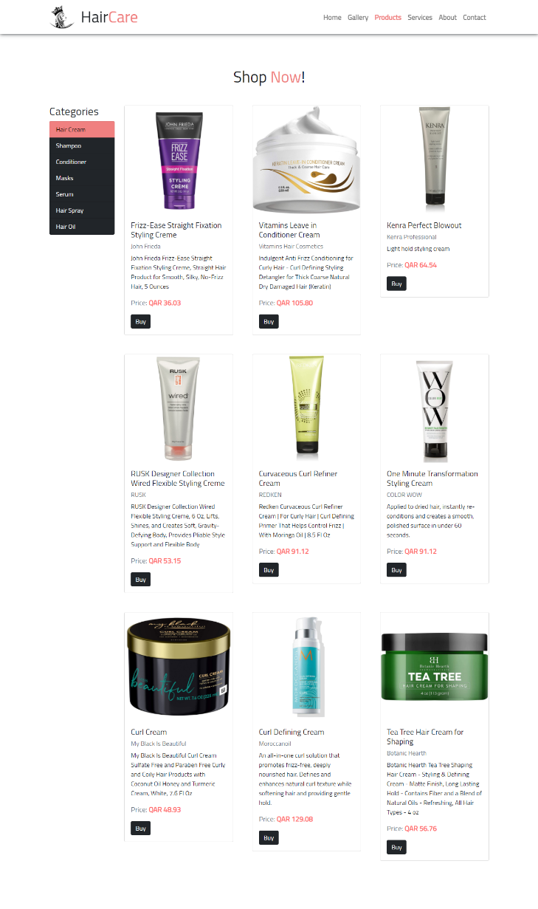

 Users can zoom the products if needed.

You can also browse through the different types of products like Hair Creams, Shampoos, Conditioners, etc.



To purchase a product, simple click on the “Buy” button and it’ll redirect you to amazon.com.



The FAQ section helps the users with any question they have regarding hair products.

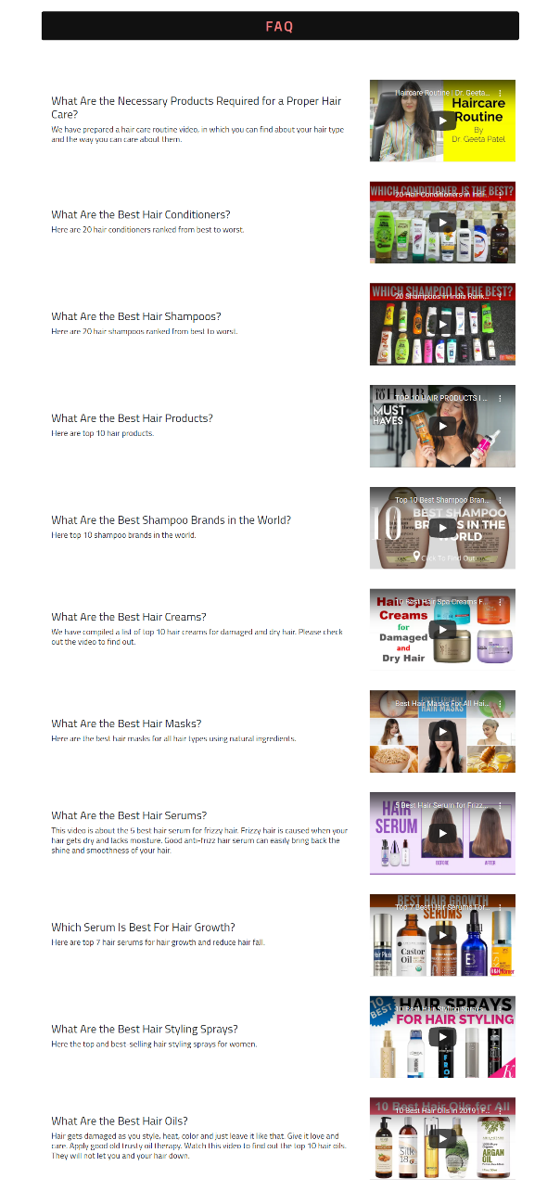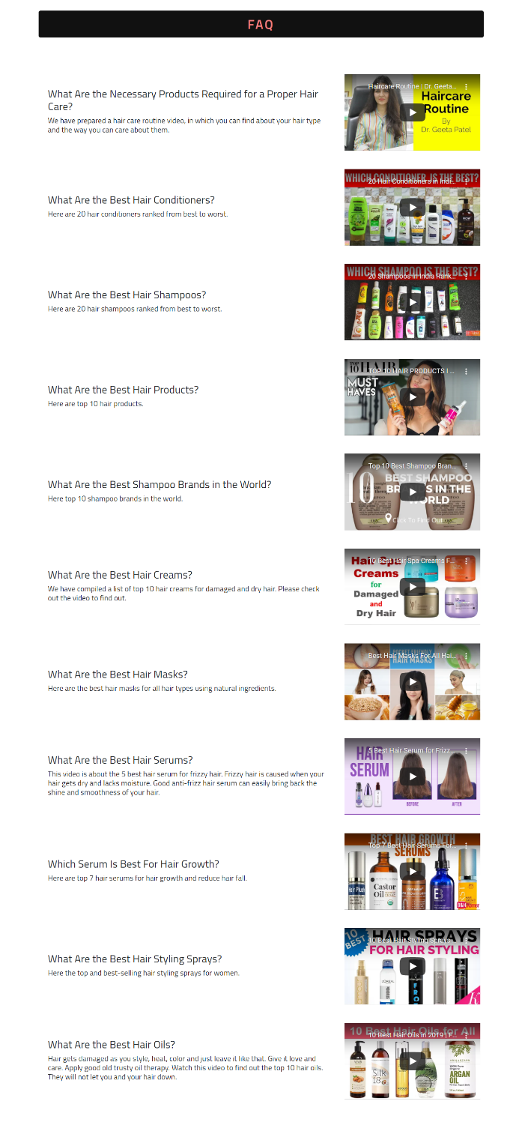

That was the end of products page.

1. Services
2. Treatments

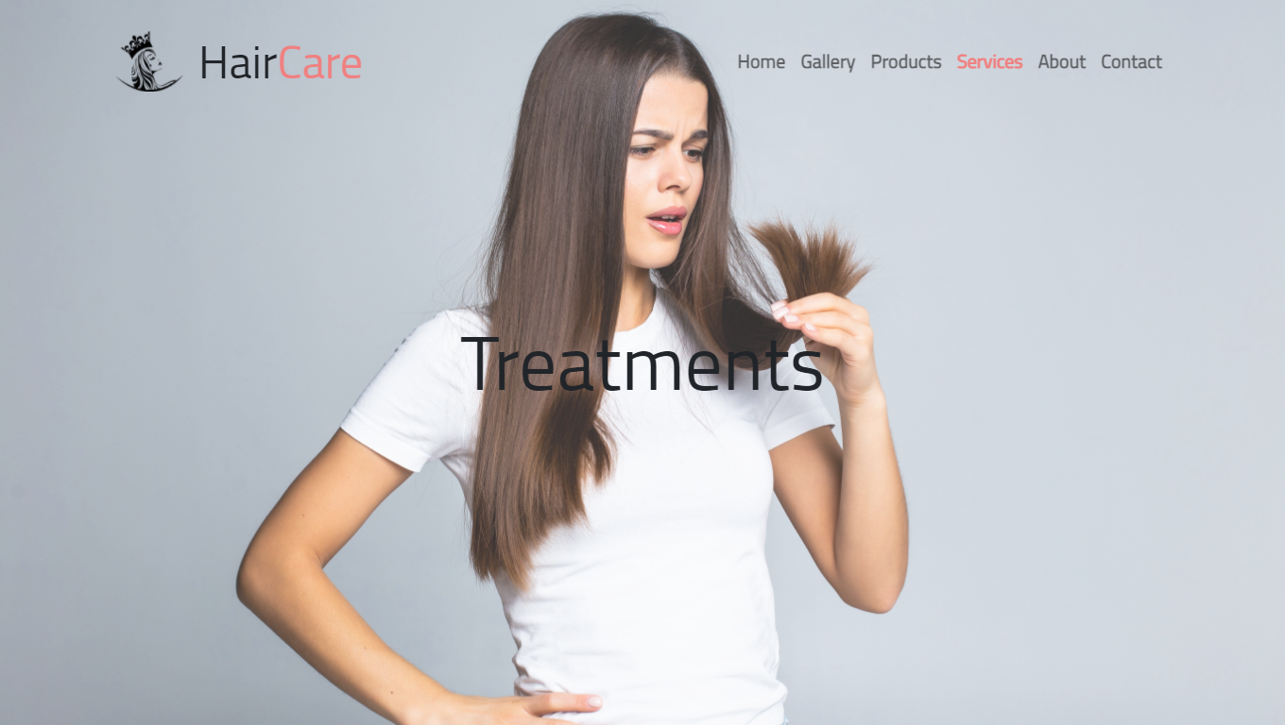

On this page, users can find many solutions to different types of hair problems.

You can browse the page using the table of contents provided on the very top, just below the hero image.

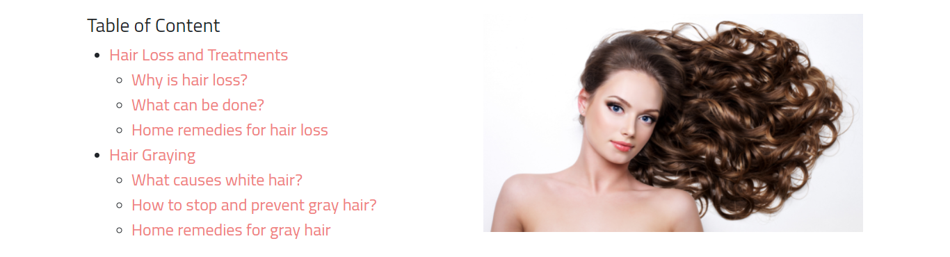

First, the user will shown why is problem happening.

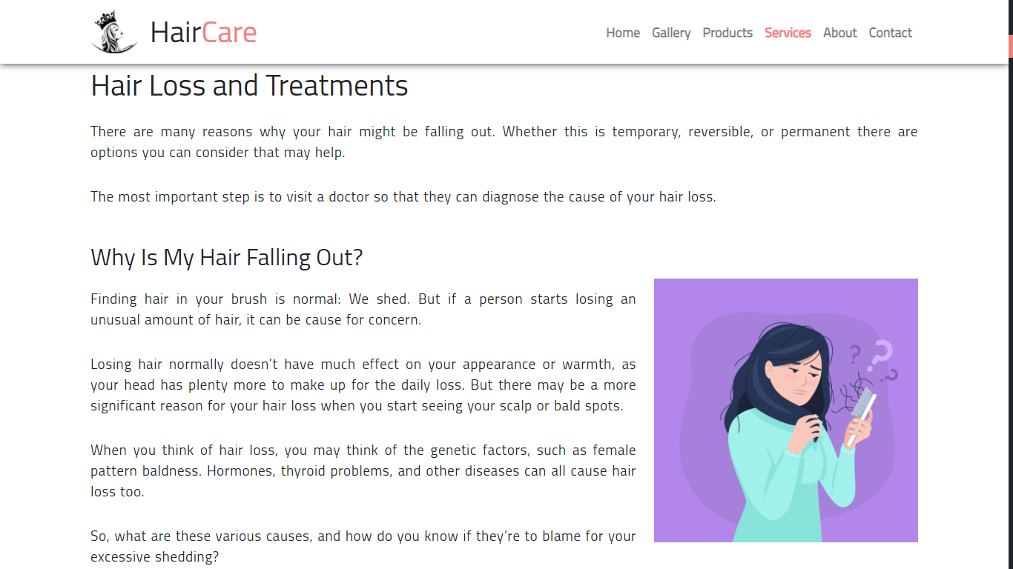

They’ll also be shown what they products they’re missing out, and are offered to visit our store, the products page.

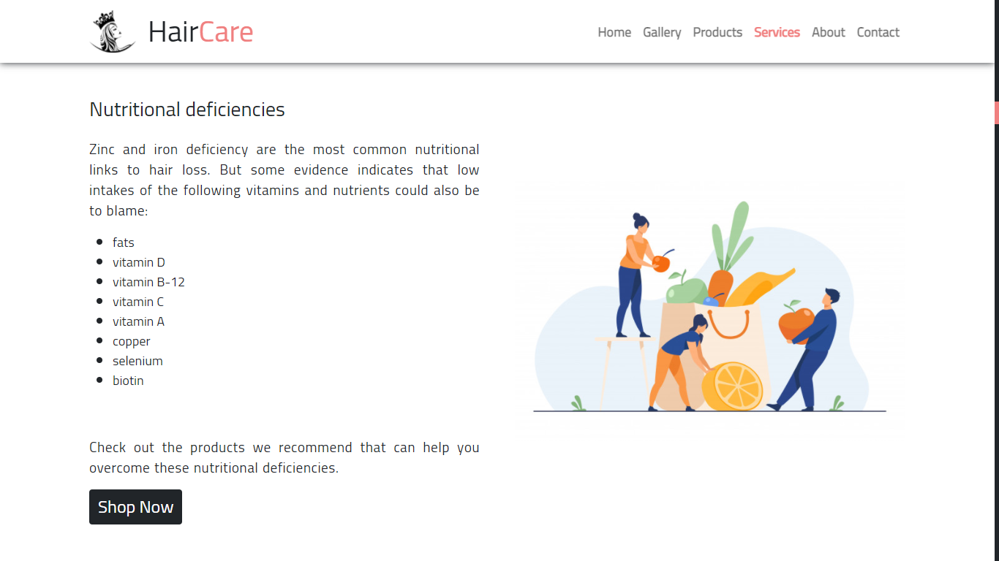

Then, the solution to your hair problem is provided.

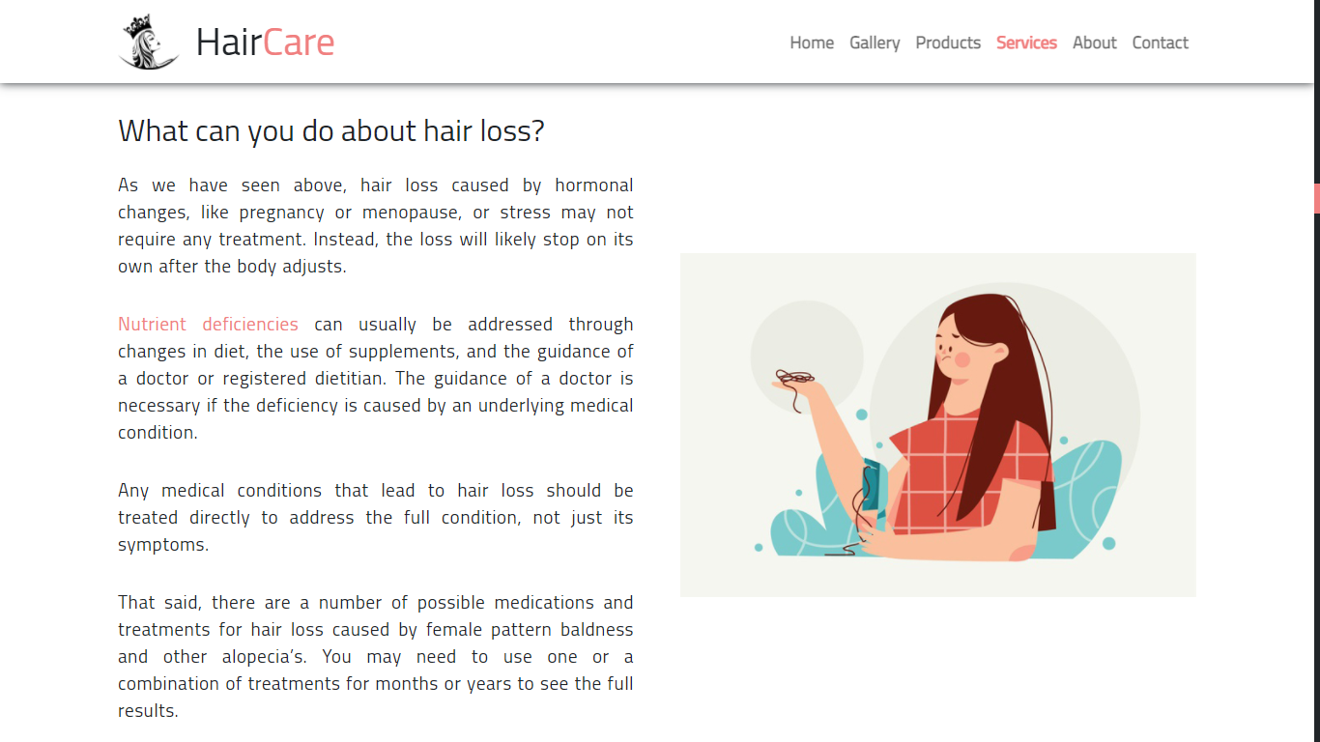

Not just one but many different solutions to different types of hair and hair problems.

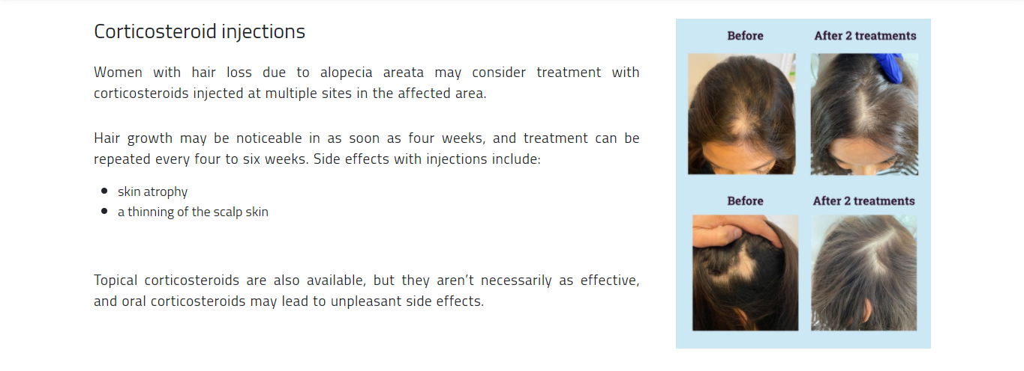

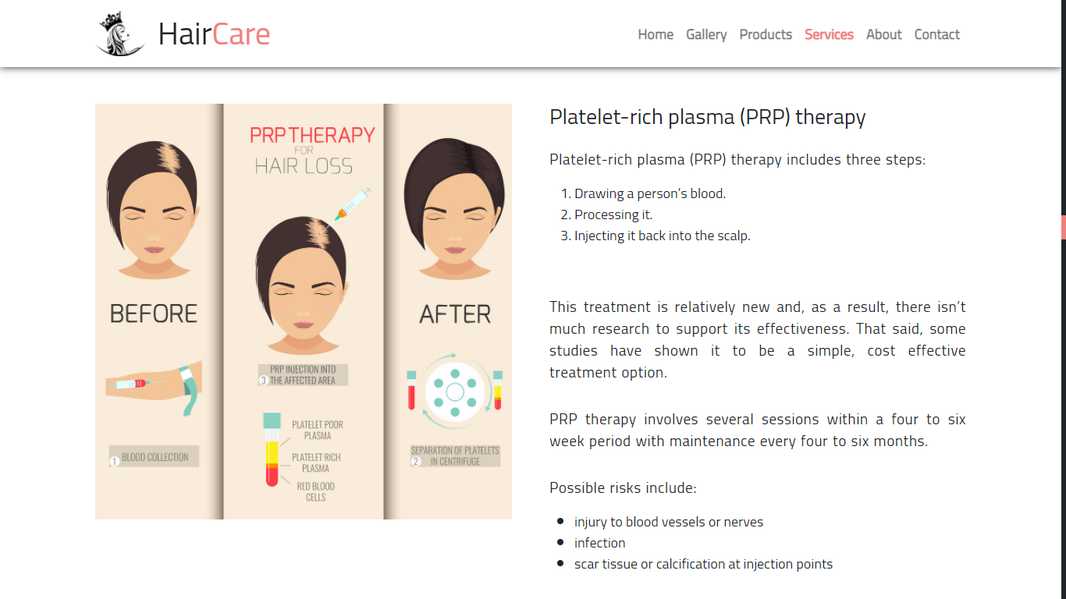

Products that can treat your hair are also displayed.

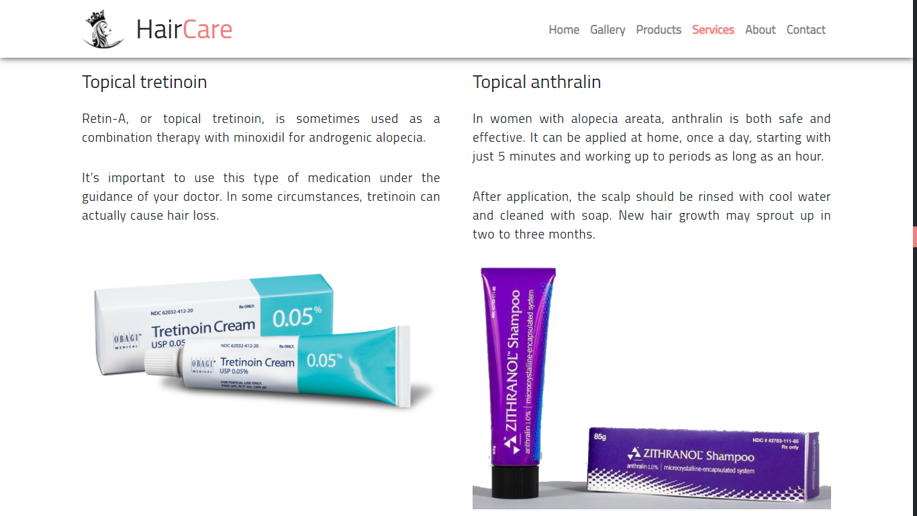

Sometimes, a issue is not that big to concern a doctor. Sometimes, problems can be solved by yourself. We have also provided home remedies that help you treat you hair.

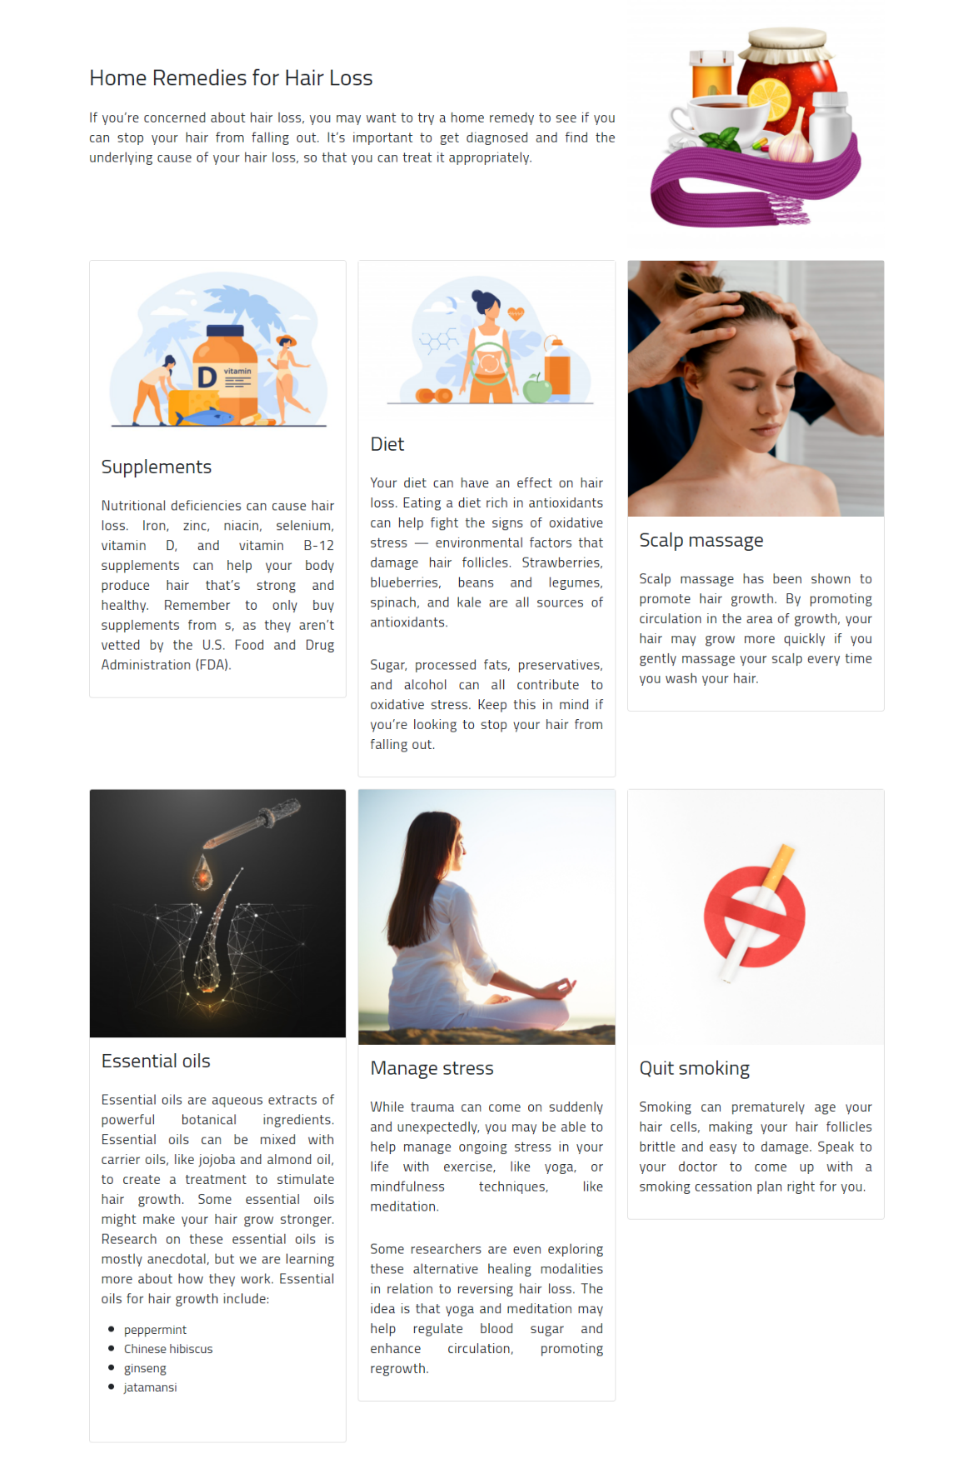

1. Equipments

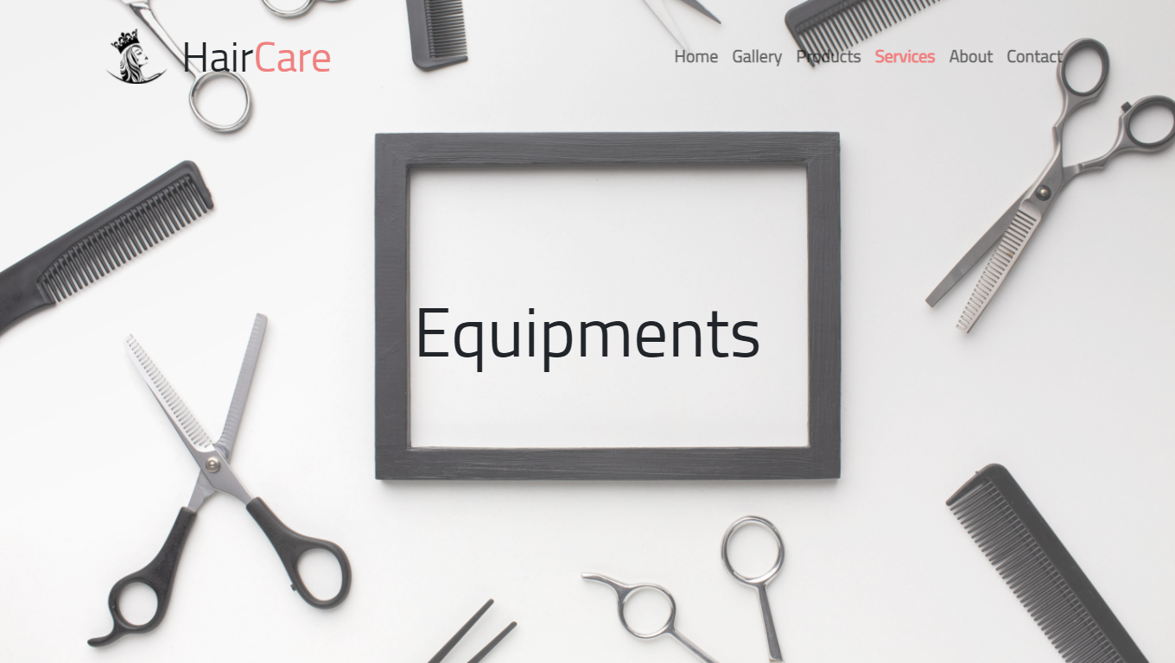

Just like in the previous services page, we have also provided here a table of content for ease of access.

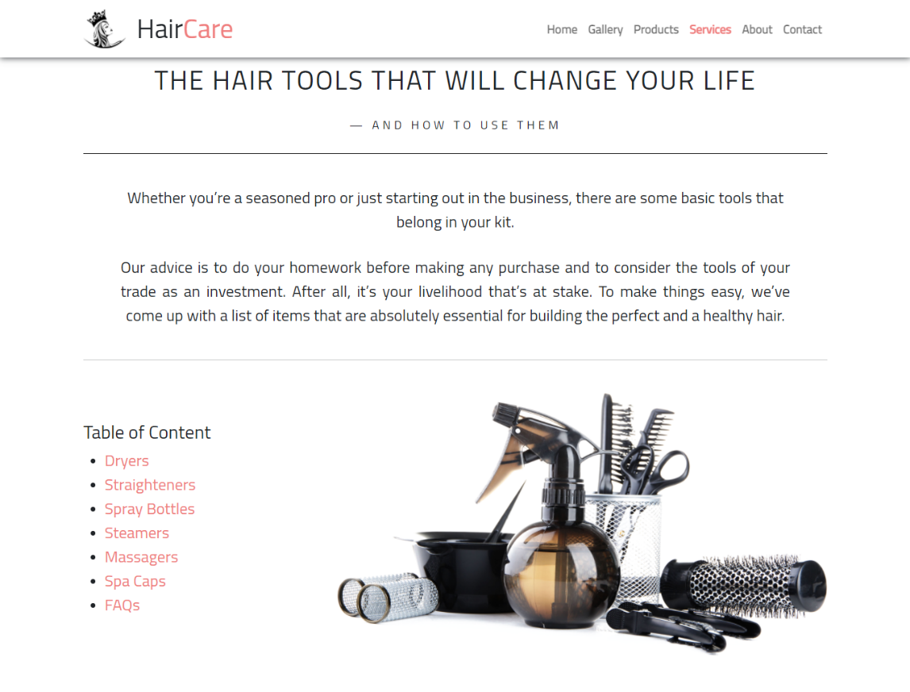

On this page, we’ve listed different types of hair equipments of different brands with their features and prices. We’ve also provided a brief note on how to use them.

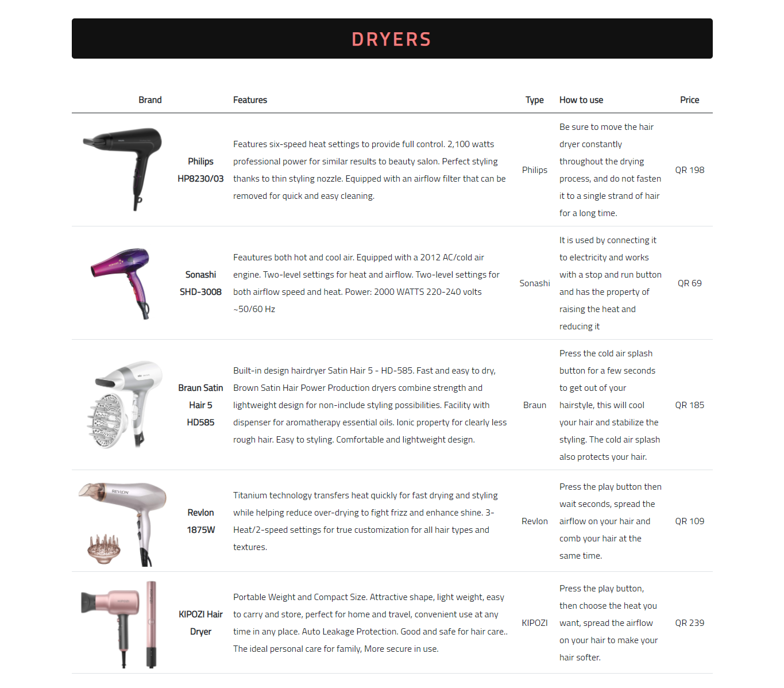

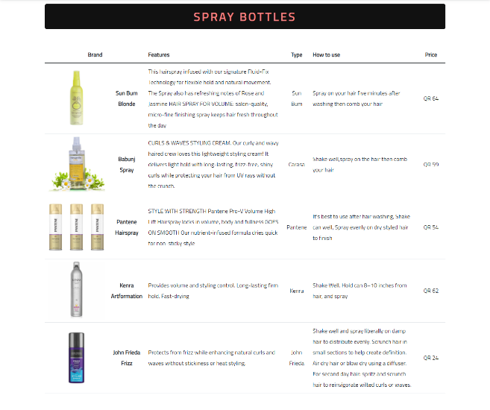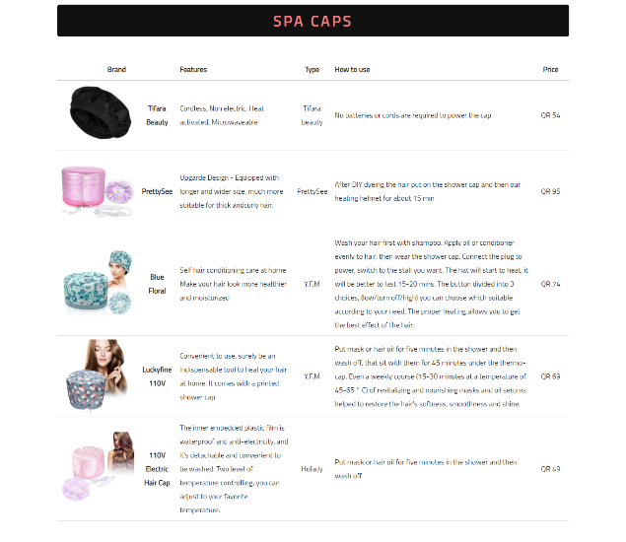

1. About Us

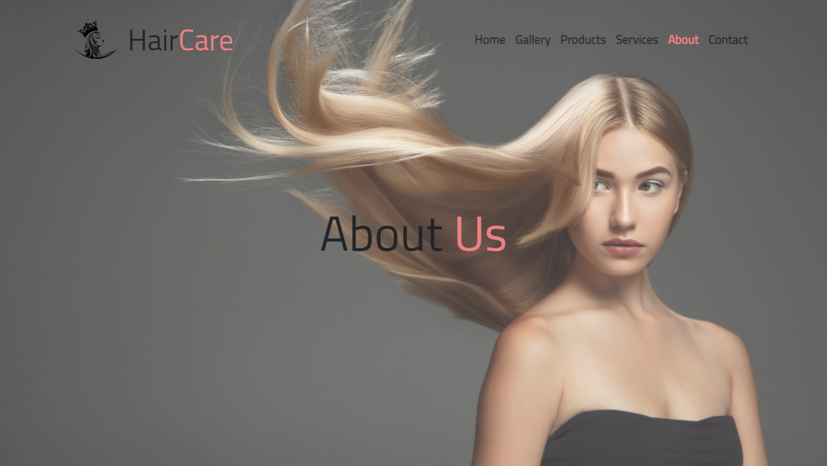

If you want to know about us, this is the page for you.

Important Information about our company are provided here.

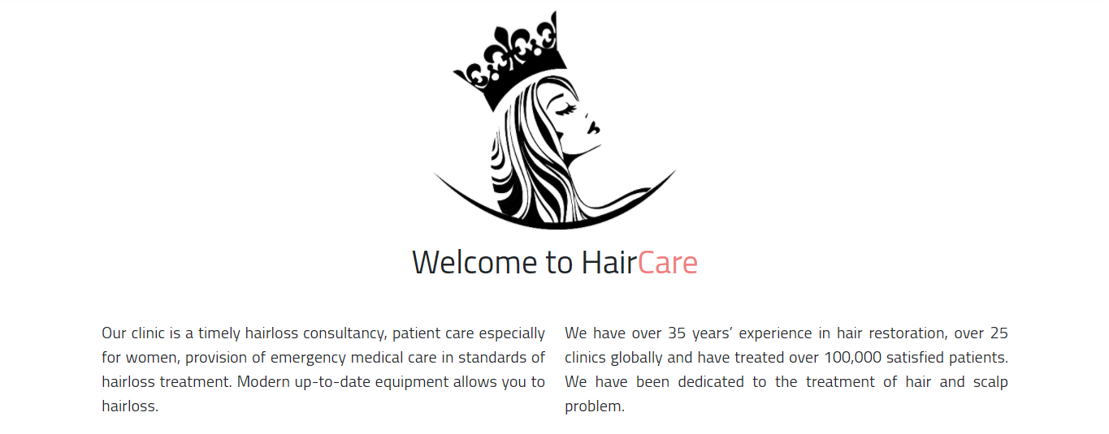

A brief description about us and the purpose of our existence are also mentioned.

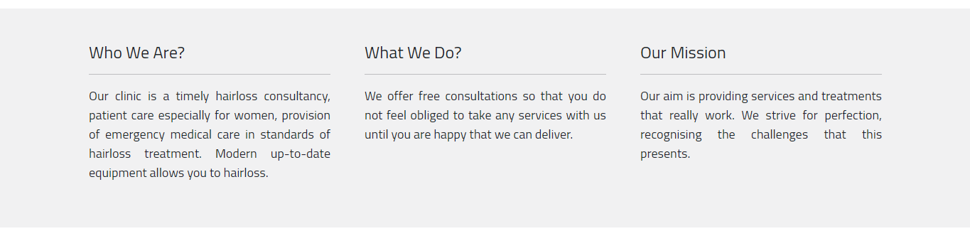

With some little-known facts.



Meet our team of experts.

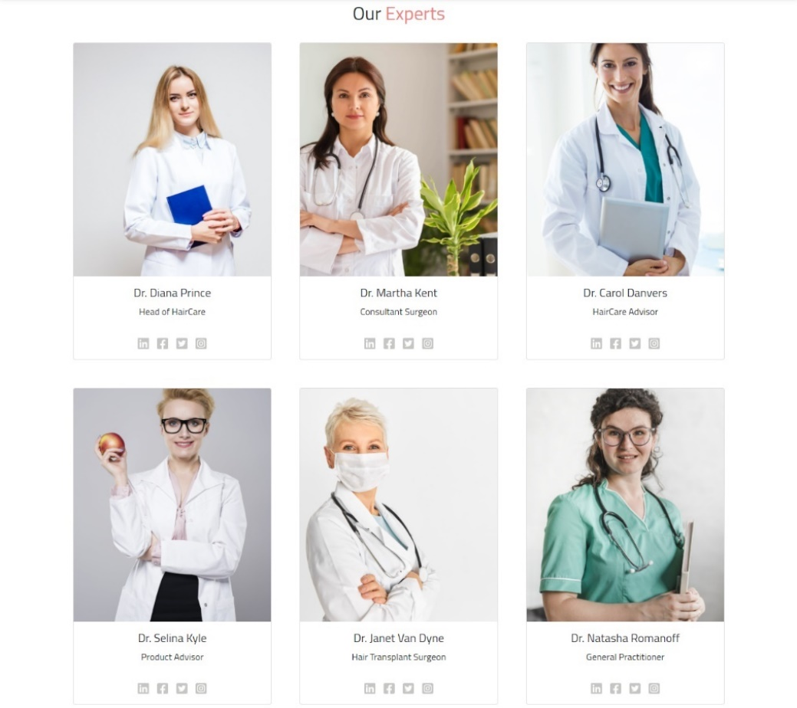

1. Contact Us

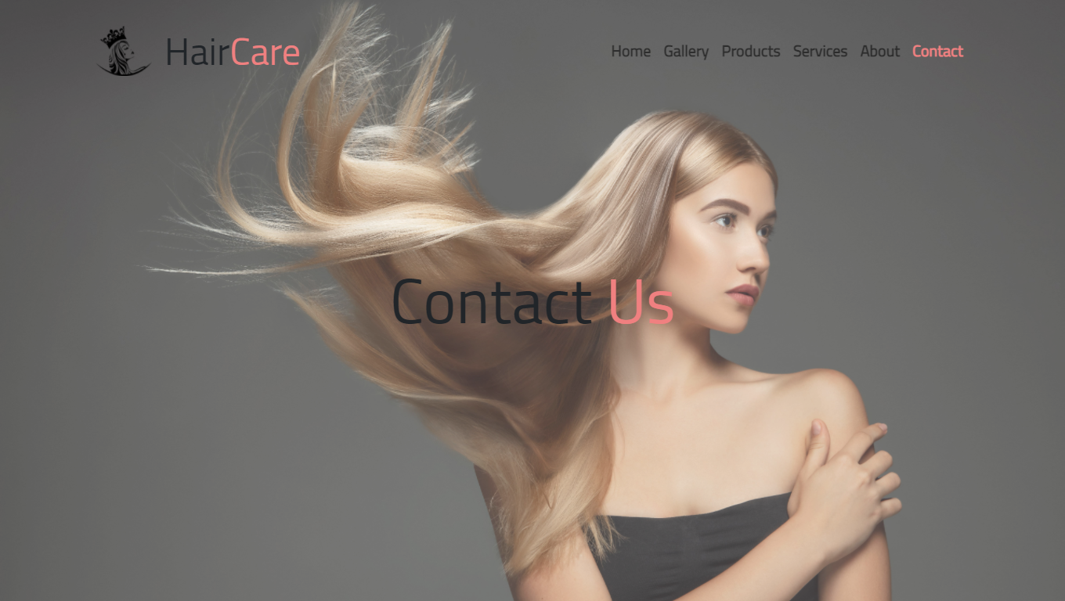

Users can contact us for consultation through our contact us page.

Find our headquarters.

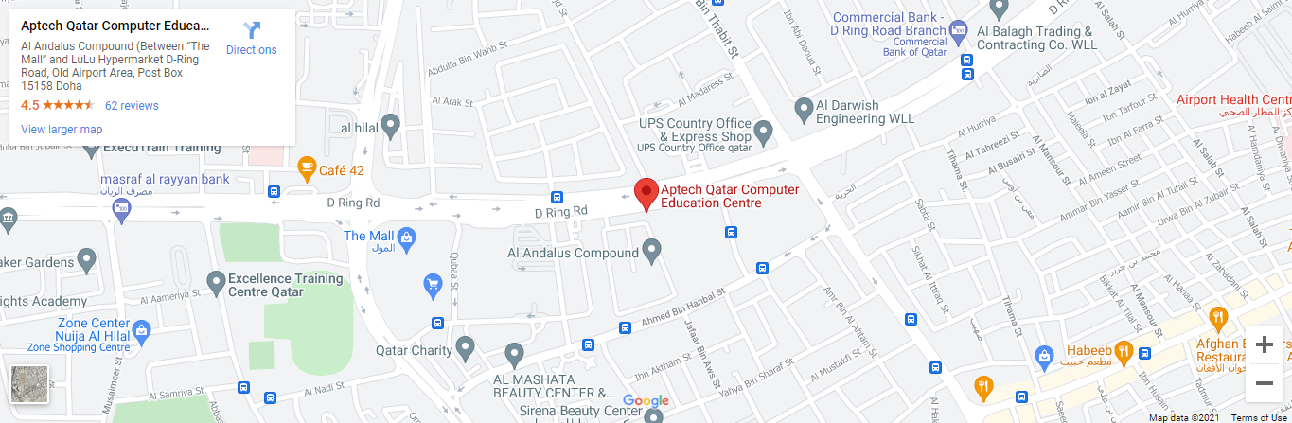

Customer care available 24/7.



Users can use the the contact form for consultation, inquiries, or to feedback.

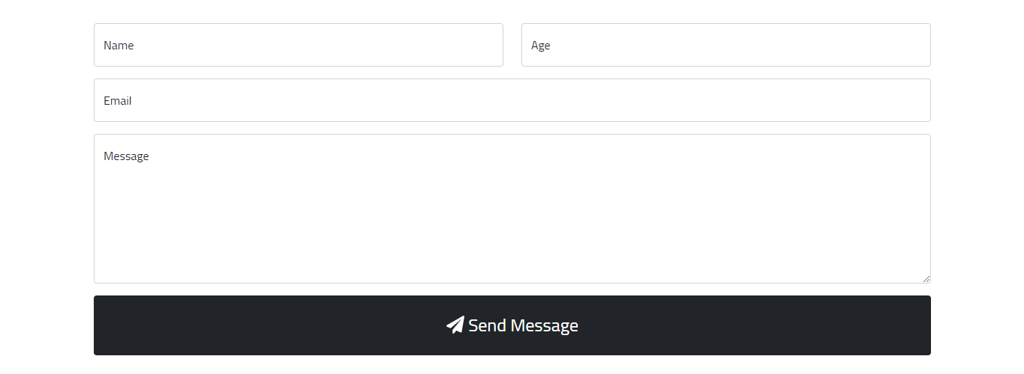

Developer’s Guide

This website is designed using three programming languages.

Programming Languages:

1. HTML5
2. CSS3
3. JavaScript

Tecnologies Used:

1. Bootstrap v5.0.0-beta3
2. Font Awesome v5.15.3 icons

Features:

* Latest browser compaibility
* Doesn’t need an internet connection to test the website
* User-friendly
* Easy navigation

Software used to write the code:

* Visual Studio Code

Source Code

1. HTML

The following codes are common on all pages.

1. The <head> Element

<head>

  <meta charset="utf-8">

  <meta content="width=device-width, initial-scale=1.0" name="viewport">

  <!--===== CSS =====-->

  <link rel="stylesheet" href="assets/css/bootstrap.min.css">

  <link rel="stylesheet" href="assets/fontawesome-icons/css/all.min.css">

  <link rel="stylesheet" href="assets/css/style.css">

  <!--===== END OF CSS =====-->

  <title>HairCare</title>

  <link rel="shortcut icon" href="images/logo.png" type="image/x-icon">

</head>

The head element consists of meta element which helps to make the site responsive.

All the CSS files are also linked inside the head element.

The page title and favicon are also places inside the head element.

1. The Navigation bar

  <nav class="navbar fixed-top navbar-expand-lg navbar-light fs-5">

    <div class="container">

      <div class="navbar-brand">

        <a href=""><img src="images/logo.png" alt=""><span class="align-middle"><span>Hair</span>Care</span></a>

      </div>

      <button class="navbar-toggler" type="button" data-bs-toggle="collapse" data-bs-target="#navMobile"

        aria-controls="navMobile" aria-expanded="false" aria-label="Toggle navigation">

        <span class="navbar-toggler-icon"></span>

      </button>

      <div class="collapse navbar-collapse" id="navMobile">

        <div class="navbar-nav ms-auto">

          <a class="nav-link active" href="index.html">Home</a>

          <a class="nav-link" href="gallery.html">Gallery</a>

          <a class="nav-link" href="products.html">Products</a>

          <li class="nav-item dropdown">

            <a class="nav-link dropdown-toggle" id="services" role="button" data-bs-toggle="dropdown">Services</a>

            <ul class="dropdown-menu dropdown-menu-dark dropdown-menu-lg-end" aria-labelledby="services">

              <li><a class="dropdown-item" href="services/treatments.html">Treatments</a></li>

              <li><a class="dropdown-item" href="services/equipments.html">Equipments</a></li>

            </ul>

          </li>

          <a class="nav-link" href="about.html">About</a>

          <a class="nav-link" href="contact.html">Contact</a>

        </div>

      </div>

    </div>

  </nav>

The navigation bar or the menu bar is created with the help of Bootstrap.

1. The Hero Section

  <section class="hero">

    <div id="herocarousel" class="carousel slide carousel-dark" data-bs-ride="carousel">

      <div class="carousel-indicators">

        <button type="button" data-bs-target="#herocarousel" data-bs-slide-to="0" class="active" aria-current="true"

          aria-label="Slide 1"></button>

        <button type="button" data-bs-target="#herocarousel" data-bs-slide-to="1" aria-label="Slide 2"></button>

        <button type="button" data-bs-target="#herocarousel" data-bs-slide-to="2" aria-label="Slide 3"></button>

      </div>

      <div class="carousel-inner">

        <div class="carousel-item active">

          <img src="images/herobg/hero-home-1.jpg">

          <div class="carousel-caption">

            <h1>Hair<span class="logocolor">Care</span></h1>

            <p>At our world-class hair care clinic, we treat hair of all ethnicity, ensuring that our patients always

              get the best diagnosis and treatment.</p>

          </div>

        </div>

        <div class="carousel-item">

          <img src="images/herobg/hero-home-2.jpg">

          <div class="carousel-caption">

            <h1>Highly-Trained <span class="logocolor">Specialists</span></h1>

            <p>We treat and diagnose using scans, biopsy or blood tests. Treating the cause and not just the symptom is

              the best way to ensure a full head of healthier hair.</p>

          </div>

        </div>

        <div class="carousel-item">

          <img src="images/herobg/hero-home-3.jpg">

          <div class="carousel-caption">

            <h1>Hair <span class="logocolor">Treatment</span></h1>

            <p>We are leaders in hair treatment, with a combined expertise of nearly 20 years, and a team of skilled

              hair specialists and surgeons.</p>

          </div>

        </div>

      </div>

    </div>

  </section>

The index.html is the only page that uses a Bootstrap carousel, an image slider. Rest all pages’ hero sections consist on an image and a heading.

  <section class="hero">

    <div class="hero-container">

      <img src="images/herobg/hero-gallery.jpg">

      <h1 class="logocolor">Gallery</h1>

    </div>

  </section>

1. The Footer

  <footer class="footer bg-dark py-5">

    <div class="container">

      <img src="images/logo.png">

      <h2>Hair<span>Care</span></h2>

      <div class="socialMedia">

        <a href=""><i class="fab fa-facebook fa-3x"></i></a>

        <a href=""><i class="fab fa-twitter fa-3x"></i></a>

        <a href=""><i class="fab fa-instagram fa-3x"></i></a>

      </div>

      <span>

        &copy; 2021 Designed by <strong><span>Aptech Students</span></strong>

      </span>

    </div>

  </footer>

1. The Script Element

  <script src="assets/js/bootstrap.bundle.min.js"></script>

  <script src="assets/fontawesome-icons/js/all.min.js"></script>

  <script src="assets/js/script.js"></script>

The following codes are of different pages.

[ Page: index.html ]

  <!--===== HOME SECTION =====-->

  <section class="home">

    <div class="container">

      <div class="intro">

        <h1>Why Hair<span class="logocolor">Care</span>?</h1>

        <p>Hair is probably one of the first things you notice about people when meeting them for the first time. This

          is

          especially true for women. Beautiful and shiny hair always leaves good impression, which is why proper hair

          care

          is

          important. Also, good care of your hair plays an important part in having healthy hair and helps avoid

          extensive

          damage that can lead to hair loss. Regular washing with celebrity advertised shampoos and conditioners is not

          enough. To have a healthy, strong and shiny hair, you need to know HOW to care for it daily.

          <i><span>

              We in Hair<i class="logocolor">Care</i> are here to help you <b></b><i class="logocolor">build a

                healthy, strong and shiny hair!</i></b>

            </span></i>

        </p>

      </div>

      <div class="offer">

        <h1>What We <span class="logocolor">Offer</span></h1>

        <div class="row g-5">

          <div class="col-lg-4">

            <div class="card shadow">

              <img src="images/home/offer-1.jpg" class="card-img">

              <div class="card-img-overlay">

                <h1 class="card-title">Consultantation</h1>

              </div>

            </div>

          </div>

          <div class="col-lg-4">

            <div class="card shadow">

              <img src="images/home/offer-2.jpg" class="card-img">

              <div class="card-img-overlay">

                <h1 class="card-title">Hair Treatments</h1>

              </div>

            </div>

          </div>

          <div class="col-lg-4">

            <div class="card shadow">

              <img src="images/home/offer-3.jpg" class="card-img">

              <div class="card-img-overlay">

                <h1 class="card-title">Hair Products</h1>

              </div>

            </div>

          </div>

        </div>

      </div>

    </div>

  </section>

  <section class="featured">

    <div class="container">

      <div class="row g-5">

        <div class="col-lg-6">

          <h1>We Have the <span class="logocolor">Solution</span> to All Your <text class="logocolor">Hair

              Problems</text>!

          </h1>

          <a class="btn btn-dark" href="services/treatments.html">Treat Now</a>

        </div>

        <div class="col-lg-6">

          <img src="images/home/featured-1.jpg" />

        </div>

        <div class="col-lg-6">

          <img src="images/home/featured-2.jpg" />

        </div>

        <div class="col-lg-6">

          <h1>Check Out the <span class="logocolor">New Shampoo</span> by TRESemmé!</h1>

          <a class="btn btn-dark" href="products.html">Shop Now</a>

        </div>

        <div class="col-lg-6">

          <h1>We Have <span class="logocolor">100K+</span> Happy Clients.</h1>

          <a class="btn btn-dark" href="about.html">Know More</a>

        </div>

        <div class="col-lg-6">

          <img src="images/home/featured-3.jpg" />

        </div>

      </div>

    </div>

  </section>

  <!--===== END OF HOME SECTION =====-->

  <section class="gallery-demo">

    <h2><a href="gallery.html">Visit Our Gallery</a></h2>

  </section>

  <div class="home-footer">

    <h4>SHARE YOUR GOOD HAIR DAY</h4>

    <h1>#Hair<span class="logocolor">Care</span></h1>

    <h5>Connect With Us!</h5>

  </div>

[ Page: gallery.html ]

  <!--===== GALLERY SECTION =====-->

  <section class="gallery bg-dark">

    <h1>Our Clients</h1>

    <div class="gallery-box row g-0" data-bs-toggle="modal" data-bs-target="#galleryModal">

      <div class="col-6 col-md-4 col-lg-3">

        <div class="gallery-img-box">

          <img src="images/gallery/gallery-1.jpg" width="100%" data-bs-target="#galleryCarousel" data-bs-slide-to="0">

        </div>

      </div>

      <div class="col-6 col-md-4 col-lg-3">

        <div class="gallery-img-box">

          <img src="images/gallery/gallery-2.jpg" width="100%" data-bs-target="#galleryCarousel" data-bs-slide-to="1">

        </div>

      </div>

      <div class="col-6 col-md-4 col-lg-3">

        <div class="gallery-img-box">

          <img src="images/gallery/gallery-3.jpg" width="100%" data-bs-target="#galleryCarousel" data-bs-slide-to="2">

        </div>

      </div>

      <div class="col-6 col-md-4 col-lg-3">

        <div class="gallery-img-box">

          <img src="images/gallery/gallery-4.jpg" width="100%" data-bs-target="#galleryCarousel" data-bs-slide-to="3">

        </div>

      </div>

      <div class="col-6 col-md-4 col-lg-3">

        <div class="gallery-img-box">

          <img src="images/gallery/gallery-5.jpg" width="100%" data-bs-target="#galleryCarousel" data-bs-slide-to="4">

        </div>

      </div>

      <div class="col-6 col-md-4 col-lg-3">

        <div class="gallery-img-box">

          <img src="images/gallery/gallery-6.jpg" width="100%" data-bs-target="#galleryCarousel" data-bs-slide-to="5">

        </div>

      </div>

      <div class="col-6 col-md-4 col-lg-3">

        <div class="gallery-img-box">

          <img src="images/gallery/gallery-7.jpg" width="100%" data-bs-target="#galleryCarousel" data-bs-slide-to="6">

        </div>

      </div>

      <div class="col-6 col-md-4 col-lg-3">

        <div class="gallery-img-box">

          <img src="images/gallery/gallery-8.jpg" width="100%" data-bs-target="#galleryCarousel" data-bs-slide-to="7">

        </div>

      </div>

      <div class="col-6 col-md-4 col-lg-3">

        <div class="gallery-img-box">

          <img src="images/gallery/gallery-9.jpg" width="100%" data-bs-target="#galleryCarousel" data-bs-slide-to="8">

        </div>

      </div>

      <div class="col-6 col-md-4 col-lg-3">

        <div class="gallery-img-box">

          <img src="images/gallery/gallery-10.jpg" width="100%" data-bs-target="#galleryCarousel" data-bs-slide-to="9">

        </div>

      </div>

      <div class="col-6 col-md-4 col-lg-3">

        <div class="gallery-img-box">

          <img src="images/gallery/gallery-11.jpg" width="100%" data-bs-target="#galleryCarousel" data-bs-slide-to="10">

        </div>

      </div>

      <div class="col-6 col-md-4 col-lg-3">

        <div class="gallery-img-box">

          <img src="images/gallery/gallery-12.jpg" width="100%" data-bs-target="#galleryCarousel" data-bs-slide-to="11">

        </div>

      </div>

      <div class="col-6 col-md-4 col-lg-3">

        <div class="gallery-img-box">

          <img src="images/gallery/gallery-13.jpg" width="100%" data-bs-target="#galleryCarousel" data-bs-slide-to="12">

        </div>

      </div>

      <div class="col-6 col-md-4 col-lg-3">

        <div class="gallery-img-box">

          <img src="images/gallery/gallery-14.jpg" width="100%" data-bs-target="#galleryCarousel" data-bs-slide-to="13">

        </div>

      </div>

      <div class="col-6 col-md-4 col-lg-3">

        <div class="gallery-img-box">

          <img src="images/gallery/gallery-15.jpg" width="100%" data-bs-target="#galleryCarousel" data-bs-slide-to="14">

        </div>

      </div>

      <div class="col-6 col-md-4 col-lg-3">

        <div class="gallery-img-box">

          <img src="images/gallery/gallery-16.jpg" width="100%" data-bs-target="#galleryCarousel" data-bs-slide-to="15">

        </div>

      </div>

      <div class="col-6 col-md-4 col-lg-3">

        <div class="gallery-img-box">

          <img src="images/gallery/gallery-17.jpg" width="100%" data-bs-target="#galleryCarousel" data-bs-slide-to="16">

        </div>

      </div>

      <div class="col-6 col-md-4 col-lg-3">

        <div class="gallery-img-box">

          <img src="images/gallery/gallery-18.jpg" width="100%" data-bs-target="#galleryCarousel" data-bs-slide-to="17">

        </div>

      </div>

      <div class="col-6 col-md-4 col-lg-3">

        <div class="gallery-img-box">

          <img src="images/gallery/gallery-19.jpg" width="100%" data-bs-target="#galleryCarousel" data-bs-slide-to="18">

        </div>

      </div>

      <div class="col-6 col-md-4 col-lg-3">

        <div class="gallery-img-box">

          <img src="images/gallery/gallery-20.jpg" width="100%" data-bs-target="#galleryCarousel" data-bs-slide-to="19">

        </div>

      </div>

      <h1>Products</h1>

      <div class="col-6 col-md-4 col-lg-3">

        <div class="gallery-img-box">

          <img src="images/gallery/gallery-21.jpg" width="100%" data-bs-target="#galleryCarousel" data-bs-slide-to="20">

        </div>

      </div>

      <div class="col-6 col-md-4 col-lg-3">

        <div class="gallery-img-box">

          <img src="images/gallery/gallery-22.png" width="100%" data-bs-target="#galleryCarousel" data-bs-slide-to="21">

        </div>

      </div>

      <div class="col-6 col-md-4 col-lg-3">

        <div class="gallery-img-box">

          <img src="images/gallery/gallery-23.jpg" width="100%" data-bs-target="#galleryCarousel" data-bs-slide-to="22">

        </div>

      </div>

      <div class="col-6 col-md-4 col-lg-3">

        <div class="gallery-img-box">

          <img src="images/gallery/gallery-24.jpg" width="100%" data-bs-target="#galleryCarousel" data-bs-slide-to="23">

        </div>

      </div>

      <div class="col-6 col-md-4 col-lg-3">

        <div class="gallery-img-box">

          <img src="images/gallery/gallery-25.jpg" width="100%" data-bs-target="#galleryCarousel" data-bs-slide-to="24">

        </div>

      </div>

      <div class="col-6 col-md-4 col-lg-3">

        <div class="gallery-img-box">

          <img src="images/gallery/gallery-26.jpg" width="100%" data-bs-target="#galleryCarousel" data-bs-slide-to="25">

        </div>

      </div>

      <div class="col-6 col-md-4 col-lg-3">

        <div class="gallery-img-box">

          <img src="images/gallery/gallery-27.jpg" width="100%" data-bs-target="#galleryCarousel" data-bs-slide-to="26">

        </div>

      </div>

    </div>

    <!-- Modal -->

    <div class="modal fade" id="galleryModal" tabindex="-1" aria-labelledby="galleryModalLabel" aria-hidden="true">

      <div class="modal-dialog modal-dialog-centered modal-dialog-scrollable">

        <div class="modal-content bg-dark">

          <button type="button" class="btn-close" data-bs-dismiss="modal" aria-label="Close"></button>

          <div class="modal-body">

            <div id="galleryCarousel" class="carousel slide" data-bs-ride="carousel">

              <div class="carousel-inner">

                <div class="carousel-item active">

                  <img src="images/gallery/gallery-1.jpg" width="100%">

                  <div class="carousel-caption">

                    <h5>Alina D'souza</h5>

                    <p>Hair Loss Patient</p>

                  </div>

                </div>

                <div class="carousel-item">

                  <img src="images/gallery/gallery-2.jpg" width="100%">

                  <div class="carousel-caption">

                    <h5>Alina D'souza</h5>

                    <p>Hair Loss Patient</p>

                  </div>

                </div>

                <div class="carousel-item">

                  <img src="images/gallery/gallery-3.jpg" width="100%">

                  <div class="carousel-caption">

                    <h5>Alina D'souza</h5>

                    <p>Hair Loss Patient</p>

                  </div>

                </div>

                <div class="carousel-item">

                  <img src="images/gallery/gallery-4.jpg" width="100%">

                  <div class="carousel-caption">

                    <h5>Alina D'souza</h5>

                    <p>Hair Loss Patient</p>

                  </div>

                </div>

                <div class="carousel-item">

                  <img src="images/gallery/gallery-5.jpg" width="100%">

                  <div class="carousel-caption">

                    <h5>Rachel Adams</h5>

                    <p>Hair Fall Patient</p>

                  </div>

                </div>

                <div class="carousel-item">

                  <img src="images/gallery/gallery-6.jpg" width="100%">

                  <div class="carousel-caption">

                    <h5>Sabrina</h5>

                    <p>Hair Growth Patient</p>

                  </div>

                </div>

                <div class="carousel-item">

                  <img src="images/gallery/gallery-7.jpg" width="100%">

                  <div class="carousel-caption">

                    <h5>Michelle</h5>

                    <p>Hair Grwoth Patient</p>

                  </div>

                </div>

                <div class="carousel-item">

                  <img src="images/gallery/gallery-8.jpg" width="100%">

                  <div class="carousel-caption">

                    <h5>Suizi</h5>

                    <p>Our Sponsor</p>

                  </div>

                </div>

                <div class="carousel-item">

                  <img src="images/gallery/gallery-9.jpg" width="100%">

                  <div class="carousel-caption">

                    <h5>Nikki Minaj</h5>

                    <p>Hair Graying Patient</p>

                  </div>

                </div>

                <div class="carousel-item">

                  <img src="images/gallery/gallery-10.jpg" width="100%">

                  <div class="carousel-caption">

                    <h5>Amanda Montana</h5>

                    <p>Hair Loss Patient</p>

                  </div>

                </div>

                <div class="carousel-item">

                  <img src="images/gallery/gallery-11.jpg" width="100%">

                  <div class="carousel-caption">

                    <h5>Soufi Hermandez</h5>

                    <p>Hair Growth Patient</p>

                  </div>

                </div>

                <div class="carousel-item">

                  <img src="images/gallery/gallery-12.jpg" width="100%">

                  <div class="carousel-caption">

                    <h5>Rimsha Kapoor</h5>

                    <p>Hair Thinning Patient</p>

                  </div>

                </div>

                <div class="carousel-item">

                  <img src="images/gallery/gallery-13.jpg" width="100%">

                  <div class="carousel-caption">

                    <h5>Elizabeth</h5>

                    <p>Hair Loss and Graying Patient</p>

                  </div>

                </div>

                <div class="carousel-item">

                  <img src="images/gallery/gallery-14.jpg" width="100%">

                  <div class="carousel-caption">

                    <h5>Domini</h5>

                    <p>Hair Loss Patient</p>

                  </div>

                </div>

                <div class="carousel-item">

                  <img src="images/gallery/gallery-15.jpg" width="100%">

                  <div class="carousel-caption">

                    <h5>Salina Gomez</h5>

                    <p>Hair Growth Patient</p>

                  </div>

                </div>

                <div class="carousel-item">

                  <img src="images/gallery/gallery-16.jpg" width="100%">

                  <div class="carousel-caption">

                    <h5>Rachel</h5>

                    <p>Hair Loss Patient</p>

                  </div>

                </div>

                <div class="carousel-item">

                  <img src="images/gallery/gallery-17.jpg" width="100%">

                  <div class="carousel-caption">

                    <h5>Nimbo</h5>

                    <p>Premature Baldness Patient</p>

                  </div>

                </div>

                <div class="carousel-item">

                  <img src="images/gallery/gallery-18.jpg" width="100%">

                  <div class="carousel-caption">

                    <h5>Melina Homie</h5>

                    <p>Hair Fall Patient</p>

                  </div>

                </div>

                <div class="carousel-item">

                  <img src="images/gallery/gallery-19.jpg" width="100%">

                  <div class="carousel-caption">

                    <h5>Asuri Pankoz</h5>

                    <p>Hair Loss Patient</p>

                  </div>

                </div>

                <div class="carousel-item">

                  <img src="images/gallery/gallery-20.jpg" width="100%">

                  <div class="carousel-caption">

                    <h5>Keira Knightley</h5>

                    <p>Hair Thinning Patient</p>

                  </div>

                </div>

                <div class="carousel-item">

                  <img src="images/gallery/gallery-21.jpg" width="100%">

                  <div class="carousel-caption">

                    <h5>Pantene Color Adapt Collection</h5>

                    <p>Introducing Pantene’s Pro V Color Adapt collection. Our color adapt technology senses the unique

                      needs of multi tonal hair, to let every inch, of every strand, stand out loud. Get lasting vibrant

                      color that is boldly you.</p>

                    <p>0% Parabens, Dyes, Mineral Oil</p>

                  </div>

                </div>

                <div class="carousel-item">

                  <img src="images/gallery/gallery-22.png" width="100%">

                  <div class="carousel-caption">

                    <h5>Pantene Miracle Rescue Collection</h5>

                    <p>Introducing NEW Pantene Pro-V Miracle Rescue Collection. Forgive the way you treated your hair in

                      the past and look towards the future. The Miracle Rescue collection helps to repair signs of

                      damage so that you can be ready for more!</p>

                  </div>

                </div>

                <div class="carousel-item">

                  <img src="images/gallery/gallery-23.jpg" width="100%">

                  <div class="carousel-caption">

                    <h5>Nutrient Blends Discover What's Good</h5>

                    <p>Discover treasures from around the world and solutions to restore your hair with the nutrients it

                      needs for healthy, beautiful hair with Pantene Nutrient Blends.</p>

                    <p>0% parabens, dyes, & mineral oil.</p>

                  </div>

                </div>

                <div class="carousel-item">

                  <img src="images/gallery/gallery-24.jpg" width="100%">

                  <div class="carousel-caption">

                    <h5>Pantenet Gold Series Intense Moisture</h5>

                    <p>The Gold Series Collection is a breakthrough line designed to provide strength and moisture for

                      women with relaxed, natural, or transitioning hair. This superior care and styling line was

                      created by Black PhD’s and scientists who understand the unique needs of textured hair. Each

                      product in the Gold Series collection is powered by protective conditioning and repair agents

                      formulated to work together to improve moisture, strength, elasticity, smoothness, and shine.</p>

                  </div>

                </div>

                <div class="carousel-item">

                  <img src="images/gallery/gallery-25.jpg" width="100%">

                  <div class="carousel-caption">

                    <h5>Oribe</h5>

                    <p>Transformative Professional Products</p>

                  </div>

                </div>

                <div class="carousel-item">

                  <img src="images/gallery/gallery-26.jpg" width="100%">

                  <div class="carousel-caption">

                    <h5>Oribe</h5>

                    <p>Gold Lust Collection</p>

                  </div>

                </div>

                <div class="carousel-item">

                  <img src="images/gallery/gallery-27.jpg" width="100%">

                  <div class="carousel-caption">

                    <h5>Oribe</h5>

                    <p>#OribeObsessed Set</p>

                  </div>

                </div>

              </div>

              <button class="carousel-control-prev" type="button" data-bs-target="#galleryCarousel"

                data-bs-slide="prev">

                <span class="carousel-control-prev-icon" aria-hidden="true"></span>

                <span class="visually-hidden">Previous</span>

              </button>

              <button class="carousel-control-next" type="button" data-bs-target="#galleryCarousel"

                data-bs-slide="next">

                <span class="carousel-control-next-icon" aria-hidden="true"></span>

                <span class="visually-hidden">Next</span>

              </button>

            </div>

          </div>

        </div>

      </div>

    </div>

  </section>

  <!--===== END OF GALLERY SECTION =====-->

  <div class="home-footer">

    <h4>FIND OUT US ON SOCIAL MEDIA FOR MORE!</h4>

    <h1>@Hair<span class="logocolor">Care</span></h1>

  </div>

[ products.html ]

  <section class="products">

    <div class="container">

      <div class="intro">

        <h1>Welcome to Hair<span class="logocolor">Care</span> Products</h1>

        <h3></h3>

        <div class="row g-0">

          <div class="col-lg-6 align-self-center pe-5">

            <h2>Start With Our Innovative Consultation</h2>

            <p>Over 80 factors are synthesized to create your custom formula. We start with micro details like hair

              thickness, condition, and texture, then move to the macro: the weather in your ZIP code, your workout

              routine, stress level, diet, and more. If you’re vegan or gluten-free, your Prose can be, too.</p>

            <p>By learning about your hair in its true context, we can give you products that fit—and work—better than

              anything before.</p>

            <a href="contact.html" class="btn">CONTACT US NOW</a>

          </div>

          <div class="col-lg-6">

            <img src="images/products/products-intro-1.jpg" alt="">

          </div>

          <div class="col-lg-6">

            <img src="images/products/products-intro-2.jpg" alt="">

          </div>

          <div class="col-lg-6 align-self-center ps-5">

            <h2>What goes into your HairCare is just as good as what you get out of it.</h2>

            <p>

              <h6>CERTIFIED CLEAN INGREDIENTS</h6>

              Our products are — sulfate free, paraben free, gluten free, phlathates free, cruelty free, vegetarian, and

              keratin treatment safe.

            </p>

            <p>

              <h6>SUSTAINABLY SOURCED</h6>

              We source the best ingredients gathered in the most ethical way. When we find better ways forward, we take

              them.

            </p>

            <p>

              <h6>CONSCIOUS IMPACT</h6>

              As a certified company, we keep our impact on your hair, not the planet. Recyclable materials are a

              given; carbon-neutral operations is the goal.

            </p>

          </div>

        </div>

      </div>

      <!--===== PRODUCT BRANDS =====-->

      <div class="brands">

        <h1>Trusted<span class="logocolor">Brands</span></h1>

        <div class="row my-5">

          <div class="col-sm-4 col-lg-4">

            <img src="images/brands/botanichearth.jpg" />

          </div>

          <div class="col-md-4 col-lg-4">

            <img src="images/brands/gk.jpg" />

          </div>

          <div class="col-md-4 col-lg-4">

            <img src="images/brands/JohnFrieda.jpg" />

          </div>

          <div class="col-md-4 col-lg-4">

            <img src="images/brands/Kerastase.jpg" />

          </div>

          <div class="col-md-4 col-lg-4">

            <img src="images/brands/loreal.jpg" />

          </div>

          <div class="col-md-4 col-lg-4">

            <img src="images/brands/nexxus.jpg" />

          </div>

          <div class="col-md-4 col-lg-4">

            <img src="images/brands/oribe.jpg" />

          </div>

          <div class="col-md-4 col-lg-4">

            <img src="images/brands/pantene.jpg" />

          </div>

          <div class="col-md-4 col-lg-4">

            <img src="images/brands/soapbox.jpg" />

          </div>

        </div>

      </div>

      <!--===== END OF PRODUCT BRANDS =====-->

      <div class="products-list row">

        <h1 class="text-center my-5">Shop <span class="logocolor">Now</span>!</h1>

        <!--===== PRODUCT NAVIGATION MENU [ TYPES OF PRODUCTS ] =====-->

        <div class="col-4 col-lg-2">

          <div class="products-nav">

            <h3>Categories</h3>

            <div class="list-group">

              <a class="list-group-item active" data-bs-toggle="list" href="#haircream">Hair Cream</a>

              <a class="list-group-item" data-bs-toggle="list" href="#shampoo">Shampoo</a>

              <a class="list-group-item" data-bs-toggle="list" href="#conditioners">Conditioner</a>

              <a class="list-group-item" data-bs-toggle="list" href="#masks">Masks</a>

              <a class="list-group-item" data-bs-toggle="list" href="#Serums">Serum</a>

              <a class="list-group-item" data-bs-toggle="list" href="#hairsprays">Hair Spray</a>

              <a class="list-group-item" data-bs-toggle="list" href="#hairoils">Hair Oil</a>

            </div>

          </div>

        </div>

        <!--===== END OF PRODUCT NAVIGATION MENU [ TYPES OF PRODUCTS ] =====-->

  <!--===== LIST OF PRODUCTS =====-->

        <div class="col-8 col-lg-10">

          <div class="tab-content">

            <div class="tab-pane fade show active" id="haircream">

              <div class="row g-5">

                <div class="col-lg-4">

                  <div class="card">

                    <div class="img-box">

                      <img src="images/products/haircream-1.jpg" class="card-img-top">

                    </div>

                    <div class="card-body">

                      <h5>Frizz-Ease Straight Fixation Styling Creme</h5>

                      <h6 class="mb-2 text-muted">John Frieda</h6>

                      <p>John Frieda Frizz-Ease Straight Fixation Styling Creme, Straight Hair Product

                        for Smooth, Silky, No-Frizz Hair, 5 Ounces</p>

                      <p class="price">Price: <b>QAR 36.03</b></p>

                      <a href="https://www.amazon.com/John-Frieda-Straight-Fixation-Styling/dp/B00390FH5G/"

                        target="_blank" class="btn">Buy</a>

                    </div>

                  </div>

                </div>

                <div class="col-lg-4">

                  <div class="card">

                    <div class="img-box">

                      <img src="images/products/haircream-2.jpg" class="card-img-top" alt="">

                    </div>

                    <div class="card-body">

                      <h5>Vitamins Leave in Conditioner Cream</h5>

                      <h6 class="mb-2 text-muted">Vitamins Hair Cosmetics</h6>

                      <p>Indulgent Anti Frizz Conditioning for Curly Hair - Curl Defining Styling Detangler for Thick

                        Coarse Natural Dry Damaged Hair (Keratin)</p>

                      <p class="price">Price: <b>QAR 105.80</b></p>

                      <a href="https://www.amazon.com/Vitamins-Leave-Conditioner-Cream-Detangler/dp/B0849KNVHG/"

                        target="_blank" class="btn">Buy</a>

                    </div>

                  </div>

                </div>

            </div>

            <div class="tab-pane fade" id="shampoo">

              <div class="row g-5">

                <div class="col-lg-4">

                  <div class="card">

                    <div class="img-box">

                      <img src="images/products/shampoo-1.jpg" class="card-img-top" alt="">

                    </div>

                    <div class="card-body">

                      <h5>TRESemmé Smooth and Silky Shampoo</h5>

                      <h6 class="mb-2 text-muted">TRESemmé</h6>

                      <p>TRESemmé Smooth and Silky Shampoo hair care delivers intense hydration that targets dryness and

                        locks in moisture where your hair needs it most.</p>

                      <p class="price">Price: <b>QAR 45.26</b></p>

                      <a href="https://www.amazon.com/TRESemm%C3%A9-Moisturizes-Moroccan-Professional-Salon-Healthy/dp/B08BTNS4K8/"

                        target="_blank" class="btn">Buy</a>

                    </div>

                  </div>

                </div>

                <div class="col-lg-4">

                  <div class="card">

                    <div class="img-box">

                      <img src="images/products/shampoo-2.jpg" class="card-img-top" alt="">

                    </div>

                    <div class="card-body">

                      <h5>Organic UltraShine Moisture Shampoo</h5>

                      <h6 class="mb-2 text-muted">EVOLVh</h6>

                      <p>Color Safe & Great For All Hair Types, This Shampoo Is Beloved By Discerning Stylists | (33.8

                        fl oz / 1 liter)</p>

                      <p class="price">Price: <b>QAR 272.24</b></p>

                      <a href="https://www.amazon.com/EVOLVh-Organic-UltraShine-Moisture-Shampoo/dp/B01AIQPQLS/"

                        target="_blank" class="btn">Buy</a>

                    </div>

                  </div>

                </div>

            </div>

          </div>

        </div>

Only a few examples of products are shown due to the lengthy amount of list of product codes.

      <div class="tutorialBox row g-5">

        <h2>FAQ</h2>

        <div class="col-lg-8">

          <h3>What Are the Necessary Products Required for a Proper Hair Care?</h3>

          <h5>We have prepared a hair care routine video, in which you can find about your hair type and the way you can

            care about them.</h5>

        </div>

        <div class="col-lg-4">

          <iframe width="355" height="200" src="https://www.youtube.com/embed/z6zyd6zAjX4" title="YouTube video player"

            frameborder="0"

            allow="accelerometer; autoplay; clipboard-write; encrypted-media; gyroscope; picture-in-picture"

            allowfullscreen></iframe>

        </div>

        <div class="col-lg-8">

          <h3>What Are the Best Hair Conditioners?</h3>

          <h5>Here are 20 hair conditioners ranked from best to worst.</h5>

        </div>

        <div class="col-lg-4">

          <iframe width="355" height="200" src="https://www.youtube.com/embed/tbO66nDf7r8" title="YouTube video player"

            frameborder="0"

            allow="accelerometer; autoplay; clipboard-write; encrypted-media; gyroscope; picture-in-picture"

            allowfullscreen></iframe>

        </div>

        <div class="col-lg-8">

          <h3>What Are the Best Hair Shampoos?</h3>

          <h5>Here are 20 hair shampoos ranked from best to worst.</h5>

        </div>

        <div class="col-lg-4">

          <iframe width="355" height="200" src="https://www.youtube.com/embed/qfB7tnJ-kRI" title="YouTube video player"

            frameborder="0"

            allow="accelerometer; autoplay; clipboard-write; encrypted-media; gyroscope; picture-in-picture"

            allowfullscreen></iframe>

        </div>

        <div class="col-lg-8">

          <h3>What Are the Best Hair Products?</h3>

          <h5>Here are top 10 hair products.</h5>

        </div>

        <div class="col-lg-4">

          <iframe width="355" height="200" src="https://www.youtube.com/embed/yY6WOG8tV8Q" title="YouTube video player"

            frameborder="0"

            allow="accelerometer; autoplay; clipboard-write; encrypted-media; gyroscope; picture-in-picture"

            allowfullscreen></iframe>

        </div>

        <div class="col-lg-8">

          <h3>What Are the Best Shampoo Brands in the World?</h3>

          <h5>Here top 10 shampoo brands in the world.</h5>

        </div>

        <div class="col-lg-4">

          <iframe width="355" height="200" src="https://www.youtube.com/embed/Va_3eC93byQ" title="YouTube video player"

            frameborder="0"

            allow="accelerometer; autoplay; clipboard-write; encrypted-media; gyroscope; picture-in-picture"

            allowfullscreen></iframe>

        </div>

        <div class="col-lg-8">

          <h3>What Are the Best Hair Creams?</h3>

          <h5>We have compiled a list of top 10 hair creams for damaged and dry hair. Please check out the video to find

            out.</h5>

        </div>

        <div class="col-lg-4">

          <iframe width="355" height="200" src="https://www.youtube.com/embed/t5MU-yT4q8o" title="YouTube video player"

            frameborder="0"

            allow="accelerometer; autoplay; clipboard-write; encrypted-media; gyroscope; picture-in-picture"

            allowfullscreen></iframe>

        </div>

        <div class="col-lg-8">

          <h3>What Are the Best Hair Masks?</h3>

          <h5>Here are the best hair masks for all hair types using natural ingredients.</h5>

        </div>

        <div class="col-lg-4">

          <iframe width="355" height="200" src="https://www.youtube.com/embed/lSiL83WvDGE" title="YouTube video player"

            frameborder="0"

            allow="accelerometer; autoplay; clipboard-write; encrypted-media; gyroscope; picture-in-picture"

            allowfullscreen></iframe>

        </div>

        <div class="col-lg-8">

          <h3>What Are the Best Hair Serums?</h3>

          <h5>This video is about the 5 best hair serum for frizzy hair. Frizzy hair is caused when your hair gets dry

            and lacks moisture. Good anti-frizz hair serum can easily bring back the shine and smoothness of your hair.

          </h5>

        </div>

        <div class="col-lg-4">

          <iframe width="355" height="200" src="https://www.youtube.com/embed/1LN4lPtef4M" title="YouTube video player"

            frameborder="0"

            allow="accelerometer; autoplay; clipboard-write; encrypted-media; gyroscope; picture-in-picture"

            allowfullscreen></iframe>

        </div>

        <div class="col-lg-8">

          <h3>Which Serum Is Best For Hair Growth?</h3>

          <h5>Here are top 7 hair serums for hair growth and reduce hair fall.</h5>

        </div>

        <div class="col-lg-4">

          <iframe width="355" height="200" src="https://www.youtube.com/embed/9imdxENVSjU" title="YouTube video player"

            frameborder="0"

            allow="accelerometer; autoplay; clipboard-write; encrypted-media; gyroscope; picture-in-picture"

            allowfullscreen></iframe>

        </div>

        <div class="col-lg-8">

          <h3>What Are the Best Hair Styling Sprays?</h3>

          <h5>Here the top and best-selling hair styling sprays for women.</h5>

        </div>

        <div class="col-lg-4">

          <iframe width="355" height="200" src="https://www.youtube.com/embed/gR9Gr9ISA9I" title="YouTube video player"

            frameborder="0"

            allow="accelerometer; autoplay; clipboard-write; encrypted-media; gyroscope; picture-in-picture"

            allowfullscreen></iframe>

        </div>

        <div class="col-lg-8">

          <h3>What Are the Best Hair Oils?</h3>

          <h5>Hair gets damaged as you style, heat, color and just leave it like that. Give it love and care. Apply good

            old trusty oil therapy. Watch this video to find out the top 10 hair oils. They will not let you and your

            hair down.</h5>

        </div>

        <div class="col-lg-4">

          <iframe width="355" height="200" src="https://www.youtube.com/embed/AHbK_gPtAfg" title="YouTube video player"

            frameborder="0"

            allow="accelerometer; autoplay; clipboard-write; encrypted-media; gyroscope; picture-in-picture"

            allowfullscreen></iframe>

        </div>

      </div>

    </div>

  </section>

  <!--===== END OF PRODUCTS SECTION =====-->

  <div class="products-footer">

    <h3><b>Follow Us</b> Today!</h3>

    <h4>And Get Latest Updates Of Our Products <b>Instantly!</b></h4>

    <h1><i>@HairCare</i></h1>

  </div>

[ Page: treatments.html ]

  <section class="treatments-header">

    <div class="container">

      <div class="row my-5">

        <div class="col-lg-6 align-self-center">

          <h3>Table of Content</h3>

          <ul>

            <li><a href="#hairloss">Hair Loss and Treatments</a></li>

            <ul>

              <li><a href="#whyhairloss">Why is hair loss?</a></li>

              <li><a href="#what2do">What can be done?</a></li>

              <li><a href="#hairlosshomeremedies">Home remedies for hair loss</a></li>

            </ul>

            <li><a href="#hairgraying">Hair Graying</a></li>

            <ul>

              <li><a href="grayhaircauses">What causes white hair?</a></li>

              <li><a href="#stopgrayhair">How to stop and prevent gray hair?</a></li>

              <li><a href="#grayhairhomeremedies">Home remedies for gray hair</a></li>

            </ul>

          </ul>

        </div>

        <div class="col-lg-6">

          <img src="treatments/treatments-header.jpg" width="100%">

        </div>

      </div>

    </div>

  </section>

The services page header which display the table of content.

  <section id="hairloss">

    <div class="container">

      <h1>Hair Loss and Treatments</h1>

      <p>There are many reasons why your hair might be falling out. Whether this is temporary, reversible, or permanent

        there are options you can consider that may help.</p>

      <p>The most important step is to visit a doctor so that they can diagnose the cause of your hair loss.</p>

      <div class="row my-5">

        <div class="col-lg-8">

          <h2 id="whyhairloss">Why Is My Hair Falling Out?</h2>

          <p>Finding hair in your brush is normal: We shed. But if a person starts losing an unusual amount of hair, it

            can be cause for concern.</p>

          <p>Losing hair normally doesn’t have much effect on your appearance or warmth, as your head has plenty more to

            make up for the daily loss. But there may be a more significant reason for your hair loss when you start

            seeing your scalp or bald spots.</p>

          <p>When you think of hair loss, you may think of the genetic factors, such as female pattern baldness.

            Hormones, thyroid problems, and other diseases can all cause hair loss too.</p>

          <p>So, what are these various causes, and how do you know if they’re to blame for your excessive shedding?</p>

        </div>

        <div class="col-lg-4 align-self-center">

          <img src="treatments/hairloss-1.jpg" width="100%">

        </div>

      </div>

      <div class="row g-5 my-5">

        <div class="col-lg-6">

          <h3>Hormonal changes</h3>

          <p>Women may lose hair following childbirth or while in menopause. Women who have hormonal imbalances can have

            hair loss.</p>

          <p>Aside from genetic female pattern baldness, women can lose hair as their hormonal composition changes with

            age.

            Hair loss is caused by your follicles’ response to the hormone dihydrotestosterone (DHT).</p>

        </div>

        <div class="col-lg-6">

          <h3>Thyroid disorders</h3>

          <p>Perhaps one of the most common hormone-related causes for hair loss is a thyroid problem. Both too much

            thyroid hormone (hyperthyroidism) and too little (hypothyroidism) can lead to hair loss. Treating the

            thyroid

            disorder can often reverse the hair loss.</p>

        </div>

        <div class="col-lg-6">

          <h3>Stress</h3>

          <p>Physical and psychological stress can cause hair loss. Surgery, high fevers, and blood loss can cause

            enough stress to result in excessive shedding. Childbirth can result in hair loss for several months after

            delivery.</p>

          <p>As for psychological stress, the link is less well-defined. However, many people have reported losing hair

            at times of extreme mental stress or anxiety. And hair loss for other reasons can still be stressful.</p>

          <p>The causes of physical stress are often temporary, and the hair loss subsides as the body heals.</p>

          <p>You can combat mental stress with lifestyle changes, such as:

            <ul>

              <li>daily exercise</li>

              <li>proper nutrition</li>

              <li>meditation and other stress management strategies</li>

              <li>removing known stressors from your life</li>

            </ul>

          </p>

        </div>

        <div class="col-lg-6 align-self-center">

          <img src="treatments/hairloss-2.jpg" width="100%">

        </div>

        <div class="col-lg-6">

          <h3>Medications</h3>

          <p>Pharmaceuticals can come with a long list of side effects, including hair loss. Chemotherapy is the most

            well-known cause, but others include:

            <ul>

              <li>thyroid medications</li>

              <li>some oral contraceptives</li>

              <li>beta-blockers</li>

              <li>anticonvulsants</li>

              <li>antidepressants</li>

              <li>anticoagulants</li>

              <p>These medications affect people differently and may not cause hair loss in everyone.</p>

            </ul>

          </p>

        </div>

        <div class="col-lg-6 align-self-center">

          <img src="treatments/hairloss-3.jpg" width="100%">

        </div>

        <div class="col-lg-6">

          <h3 id="NutrientDeficiencies">Nutritional deficiencies</h3>

          <p>Zinc and iron deficiency are the most common nutritional links to hair loss. But some evidence indicates

            that low intakes of the following vitamins and nutrients could also be to blame:

            <ul>

              <li>fats</li>

              <li>vitamin D</li>

              <li>vitamin B-12</li>

              <li>vitamin C</li>

              <li>vitamin A</li>

              <li>copper</li>

              <li>selenium</li>

              <li>biotin</li>

            </ul>

          </p>

          <p>Check out the products we recommend that can help you overcome these nutritional deficiencies.</p>

          <a class="btn btn-dark" href="../products.html">Shop Now</a>

        </div>

        <div class="col-lg-6 align-self-center">

          <img src="treatments/hairloss-4.jpg" width="100%">

        </div>

        <div>

          <h3>Other medical conditions</h3>

          <p>Many other medical conditions can lead to abnormal balding, including:

            <ul>

              <li>renal failure</li>

              <li>inflammatory bowel disease (IBD)</li>

              <li>liver disease</li>

              <li>diabetes</li>

            </ul>

          </p>

          <p>Skin conditions such as psoriasis and dermatitis can occur on the scalp and interfere with hair growth.

            Infections such as ringworm of the scalp and folliculitis can also cause hair loss.</p>

          <p>The search for causes and potential treatments by people experiencing hair loss is understandable. Research

            has tied hair loss to lower self-esteem, body image issues, and increased anxiety.</p>

          <p>Many of these nongenetic causes for hair loss can be successfully treated, and the hair loss averted and

            even

            reversed.</p>

          <h5>We’ll go over common, conventional, and complementary treatments available to treat hair loss.</h5>

        </div>

      </div>

      <div class="row my-5 g-5" id="what2do">

        <div class="col-lg-6">

          <h2>What can you do about hair loss?</h2>

          <p>As we have seen above, hair loss caused by hormonal changes, like pregnancy or menopause, or stress may

            not require any treatment. Instead, the loss will likely stop on its own after the body adjusts.</p>

          <p><a href="#NutrientDeficiencies">Nutrient deficiencies</a> can usually be addressed through changes in

            diet, the use of supplements, and the guidance of a doctor or registered dietitian. The guidance of a

            doctor is necessary if the deficiency is caused by an underlying medical condition.</p>

          <p>Any medical conditions that lead to hair loss should be treated directly to address the full condition,

            not just its symptoms.</p>

          <p>That said, there are a number of possible medications and treatments for hair loss caused by female

            pattern baldness and other alopecia’s. You may need to use one or a combination of treatments for months

            or years to see the full results.</p>

        </div>

        <div class="col-lg-6 align-self-center">

          <img src="treatments/hairloss-5.jpg" width="100%">

        </div>

        <div class="col-lg-6">

          <h3>Minoxidil topical solution</h3>

          <p>Also known as Rogaine, this over-the-counter (OTC) medication can be used with alopecia areata or

            androgenic alopecia.</p>

          <p>This drug comes in foam or liquid form and is spread on the scalp each day. It may cause more hair loss

            at first, and new growth may be shorter and thinner than before. You may also need to use it six months or

            more to prevent further loss and promote regrowth.</p>

          <p>Side effects include:

            <ul>

              <li>scalp irritation</li>

              <li>hair growth on other parts of the face or hands that come in contact with the medication</li>

              <li>tachycardia (rapid heart rate)</li>

            </ul>

          </p>

          <img src="treatments/hairloss-minoxidil.png" width="100%">

        </div>

        <div class="col-lg-6">

          <h3>Prescription spironolactone pills</h3>

          <p>Otherwise known as Aldactone, the drug spironolactone works to treat hair loss by addressing hormones.

            Specifically, it binds to androgen receptors and decreases the body’s processing of testosterone.</p>

          <img src="treatments/hairloss-spironolactone.jpg" width="100%">

          <p>Not all researchers agree that it works effectively, and the U.S. Food and Drug Administration (FDA) has

            not labeled it as a treatment for androgenic alopecia.</p>

          <p>Talk to a doctor or pharmacist about possible benefits and risks of spironolactone.</p>

        </div>

        <div class="col-lg-8">

          <h3>Corticosteroid injections</h3>

          <p>Women with hair loss due to alopecia areata may consider treatment with corticosteroids injected at

            multiple sites in the affected area.</p>

          <p>Hair growth may be noticeable in as soon as four weeks, and treatment can be repeated every four to six

            weeks. Side effects with injections include:

            <ul>

              <li>skin atrophy</li>

              <li>a thinning of the scalp skin</li>

            </ul>

          </p>

          <p>Topical corticosteroids are also available, but they aren’t necessarily as effective, and oral

            corticosteroids may lead to unpleasant side effects.</p>

        </div>

        <div class="col-lg-4">

          <img src="treatments/hairloss-corticosteroid-1.jpg" width="100%">

          <img src="treatments/hairloss-corticosteroid-2.jpg" width="100%">

        </div>

        <div class="col-lg-6">

          <img src="treatments/hairloss-prp.jpg" width="100%">

        </div>

        <div class="col-lg-6">

          <h3>Platelet-rich plasma (PRP) therapy</h3>

          <p>Platelet-rich plasma (PRP) therapy includes three steps:

            <ol>

              <li>Drawing a person’s blood.</li>

              <li>Processing it.</li>

              <li>Injecting it back into the scalp.</li>

            </ol>

          </p>

          <p>This treatment is relatively new and, as a result, there isn’t much research to support its

            effectiveness. That said, some studies have shown it to be a simple, cost effective

            treatment option.</p>

          <p>PRP therapy involves several sessions within a four to six week period with maintenance every four to six

            months.</p>

          <p>Possible risks include:

            <ul>

              <li>injury to blood vessels or nerves</li>

              <li>infection</li>

              <li>scar tissue or calcification at injection points</li>

            </ul>

          </p>

        </div>

        <div class="col-lg-6">

          <h3>Light and laser therapy</h3>

          <p>Laser devices may stimulate hair growth for people with androgenic alopecia and pattern balding. Other

            names of laser treatment include:

            <ul>

              <li>red light therapy</li>

              <li>cold laser</li>

              <li>soft laser</li>

              <li>photobiomodulation</li>

              <li>biostimulation</li>

            </ul>

          </p>

          <p>Devices are available without a prescription in the form of brushes, combs, and other handheld items.

            They emit light and may also make existing hair thicker.</p>

          <p>You can apply laser light treatment two to three times a week. It may take several weeks to a few months

            before seeing results.</p>

          <p>It’s important to note that laser treatment is not as regulated as medications are with the FDA.

            Long-term safety and other considerations are unknown. Currently, there are no adverse effects associated

            with laser therapy.</p>

        </div>

        <div class="col-lg-6">

          <img src="treatments/hairloss-lasertherapy.jpg" width="100%">

        </div>

        <div class="col-lg-6">

          <h3>Topical tretinoin</h3>

          <p>Retin-A, or topical tretinoin, is sometimes used as a combination therapy with minoxidil for androgenic

            alopecia.</p>

          <p>It’s important to use this type of medication under the guidance of your doctor. In some circumstances,

            tretinoin can actually cause hair loss.</p>

          <img src="treatments/hairloss-tretinoin.png" width="100%">

        </div>

        <div class="col-lg-6">

          <h3>Topical anthralin</h3>

          <p>In women with alopecia areata, anthralin is both safe and effective. It can be applied at home, once a

            day, starting with just 5 minutes and working up to periods as long as an hour.</p>

          <p>After application, the scalp should be rinsed with cool water and cleaned with soap. New hair growth may

            sprout up in two to three months.</p>

          <img src="treatments/hairloss-anthralin.jpg" width="100%">

        </div>

        <div class="col-lg-12 text-center">

          <p>Check out our store to find out hair products with tretinoin and anthralin.</p>

          <a class="btn btn-dark" href="../products.html">Online Store</a>

        </div>

      </div>

      <div class="row g-3" id="hairlosshomeremedies">

        <div class="col-lg-8 align-self-center">

          <h2>Home Remedies for Hair Loss</h2>

          <p>If you’re concerned about hair loss, you may want to try a home remedy to see if you can stop your hair

            from falling out. It’s important to get diagnosed and find the underlying cause of your hair loss, so that

            you can treat it appropriately.</p>

        </div>

        <div class="col-lg-4">

          <img src="treatments/hairloss-6.jpg" width="100%">

        </div>

        <div class="col-lg-4">

          <div class="card">

            <img src="treatments/hairloss-homeremedy-1.jpg" width="100%" class="card-img-top">

            <div class="card-body">

              <h3>Supplements</h3>

              <p>Nutritional deficiencies can cause hair loss. Iron, zinc, niacin, selenium, vitamin D, and vitamin B-12

                supplements can help your body produce hair that’s strong and healthy. Remember to only buy

                supplements from s, as they aren’t vetted by the U.S. Food and Drug Administration (FDA).</p>

            </div>

          </div>

        </div>

        <div class="col-lg-4">

          <div class="card">

            <img src="treatments/hairloss-homeremedy-4.jpg" width="100%">

            <div class="card-body">

              <h3>Diet</h3>

              <p>Your diet can have an effect on hair loss. Eating a diet rich in antioxidants can help fight the signs

                of

                oxidative stress — environmental factors that damage hair follicles. Strawberries, blueberries, beans

                and

                legumes, spinach, and kale are all sources of antioxidants.</p>

              <p>Sugar, processed fats, preservatives, and alcohol can all contribute to oxidative stress. Keep this in

                mind

                if you’re looking to stop your hair from falling out.</p>

            </div>

          </div>

        </div>

        <div class="col-lg-4">

          <div class="card">

            <img src="treatments/hairloss-homeremedy-3.jpg" width="100%">

            <div class="card-body">

              <h3>Scalp massage</h3>

              <p>Scalp massage has been shown to promote hair growth. By promoting circulation in the area of

                growth, your hair may grow more quickly if you gently massage your scalp every time you wash your hair.

              </p>

            </div>

          </div>

        </div>

        <div class="col-lg-4">

          <div class="card">

            <img src="treatments/hairloss-homeremedy-2.jpg" width="100%" class="card-img-top">

            <div class="card-body">

              <h3>Essential oils</h3>

              <p>Essential oils are aqueous extracts of powerful botanical ingredients. Essential oils can be mixed with

                carrier oils, like jojoba and almond oil, to create a treatment to stimulate hair growth. Some essential

                oils might make your hair grow stronger. Research on these essential oils is mostly anecdotal, but we

                are

                learning more about how they work. Essential oils for hair growth include:

                <ul>

                  <li>peppermint</li>

                  <li>Chinese hibiscus</li>

                  <li>ginseng</li>

                  <li>jatamansi</li>

                </ul>

              </p>

            </div>

          </div>

        </div>

        <div class="col-lg-4">

          <div class="card">

            <img src="treatments/hairloss-homeremedy-6.jpg" width="100%">

            <div class="card-body">

              <h3>Manage stress</h3>

              <p>While trauma can come on suddenly and unexpectedly, you may be able to help manage ongoing stress in

                your

                life with exercise, like yoga, or mindfulness techniques, like meditation.</p>

              <p>Some researchers are even exploring these alternative healing modalities in relation to reversing hair

                loss. The idea is that yoga and meditation may help regulate blood sugar and enhance circulation,

                promoting regrowth.</p>

            </div>

          </div>

        </div>

        <div class="col-lg-4">

          <div class="card">

            <img src="treatments/hairloss-homeremedy-5.1.jpg" width="100%">

            <div class="card-body">

              <h3>Quit smoking</h3>

              <p>Smoking can prematurely age your hair cells, making your hair follicles brittle and easy to damage.

                Speak

                to your doctor to come up with a smoking cessation plan right for you.</p>

            </div>

          </div>

        </div>

      </div>

    </div>

  </section>

  <section id="hairgraying">

    <div class="container">

      <h1>Hair Graying: What, Why & How To Reverse Premature Graying?</h1>

      <img src="treatments/hairgraying-1.jpg" width="100%" class="py-3">

      <p>Premature white hair giving you nightmares? If you’re one of those youngsters who is dealing with unwanted gray

        hair and trying to reverse it through various tricks, this article is a must-read for you.</p>

      <p>Graying hair is a part of your natural ageing process. Your skin has millions of hair follicles that contain a

        pigment called melanin. As you age, hair follicles lose this pigment turning your hair into gray. Scroll down to

        find out what causes premature graying and how you can deal with it.</p>

      <div class="row my-5 g-4">

        <h2 id="grayhaircauses">What Causes White Hair?</h2>

        <div class="col-lg-8 align-self-center">

          <h4>Genetics</h4>

          <p>According to studies, premature graying is related to genetics. It is likely that you will have

            gray hair at an early age if your mother or father had premature gray hair. It is also related to

            geography and race according to a study performed in 2013. People in a certain country can have gray

            hair much earlier than people in other countries. White people can get white hair even in their 20s,

            while Asian people most likely start getting white hair in their mid 20s. For African-Americans, the age

            of graying hair starts at 30.</p>

        </div>

        <div class="col-lg-4">

          <img src="treatments/hairgraying-2.jpg" width="100%">

        </div>

        <div class="col-lg-8 align-self-center">

          <h4>Stress</h4>

          <p>Stress can lead to a flood of problems like anxiety, high blood pressure, sleeping issues, skin disorders

            and so on. Adding to this list is premature graying of hair. Yes, stress can turn your hair gray. A study

            done in 2013 observed a link between stress and depletion of stem cells in the hair follicles of mice.</p>

        </div>

        <div class="col-lg-4">

          <img src="treatments/hairgraying-3.jpg" width="100%">

        </div>

        <div class="col-lg-8 align-self-center">

          <h4>Diet</h4>

          <p>An imbalanced diet can speed up graying of hair. Processed foods, cold drinks, excess intake of salt and

            sugar increase the risk of free radical generation in the body that can cause gray hair.</p>

        </div>

        <div class="col-lg-4">

          <img src="treatments/hairgraying-4.jpg" width="100%">

        </div>

        <div class="col-lg-8 align-self-center">

          <h4>Vitamin Deficiency</h4>

          <p>Yes, lack of vitamins like vitamin B, D, E, biotin can lead to premature graying of hair. Vitamin

            deficiencies can affect pigmentation, but can be reversed using vitamin supplements. Talk to your doctor if

            you want to incorporate supplements in your diet.</p>

        </div>

        <div class="col-lg-4">

          <img src="treatments/hairgraying-5.jpg" width="100%">

        </div>

        <div class="col-lg-8 align-self-center">

          <h4>Pollution/Weather Conditions</h4>

          <p>Pollutants in the air generate free radicals and oxidative stress. This can in turn cause damage to the

            melanin cells, speeding up hair graying.</p>

        </div>

        <div class="col-lg-4">

          <img src="treatments/hairgraying-6.jpg" width="100%">

        </div>

        <div class="col-lg-8 align-self-center">

          <h4>Oxidative Stress</h4>

          <p>Oxidative stress can be a reason behind your premature white hair. It happens when there is an imbalance

            between free radicals and antioxidants. When your antioxidants are not adequate to retaliate the effects of

            free radicals, it leads to many health issues, including ageing. Excessive oxidate causes a condition called

            vitiligo. It kills your melanin cells, leading to premature gray hair.</p>

        </div>

        <div class="col-lg-4">

          <img src="treatments/hairgraying-7.jpg" width="100%">

        </div>

        <div class="col-lg-8 align-self-center">

          <h4>Chemical Hair Products</h4>

          <p>Hair care products like shampoos and conditioners can lead to premature graying of hair, due to the

            presence of chemicals which decrease your melanin content. Hair dyes containing hydrogen peroxide and

            bleaching agents can leave the hair white when used for prolonged periods.</p>

          <p>Check out our store of chemical free products.</p>

          <a class="btn btn-dark" href="../products.html">Store</a>

        </div>

        <div class="col-lg-4">

          <img src="treatments/hairgraying-8.jpg" width="100%">

        </div>

        <div class="col-lg-8 align-self-center">

          <h4>Smoking</h4>

          <p>Smoking not only increases the risk of lung cancer and heart disease, but also puts your hair at risk.

            Smoking constricts blood vessels, reduces blood flow to hair follicles and leads to hair loss. The toxins in

            cigarette smoke can affect hair follicles causing gray hair earlier than expected.</p>

        </div>

        <div class="col-lg-4">

          <img src="treatments/hairgraying-9.jpg" width="100%">

        </div>

        <div class="col-lg-8 align-self-center">

          <h4>Medical Conditions</h4>

          <p>When you talk about the causes of premature white hair, you have to consider few medical conditions as

            contributing factors. Autoimmune disease and thyroid disorder can trigger gray hair. In autoimmune disease,

            your own immune system destroys your cells instead of protecting, which can affect your hair pigmentation

            too.</p>

          <p>Your thyroid gland also influences your hair colour. In the case of a thyroid disorder, it causes hormonal

            imbalance and reduces melanin production in your body. Naturally, your hair turns gray</p>

        </div>

        <div class="col-lg-4">

          <img src="treatments/hairgraying-10.jpg" width="100%">

        </div>

      </div>

      <div class="row my-5 g-5">

        <h2 id="stopgrayhair">How To Stop and Prevent Gray Hair?</h2>

        <div class="col-lg-6">

          <div class="card">

            <div class="card-header">

              <h4>Medicated/Doctor Prescribed Products</h4>

            </div>

            <div class="card-body">

              <p>Treatments start with the determination of the type of graying (natural or premature) and the

                underlying causes. Your doctor may give shampoos, conditioners, oils, serums and hair masks suited to

                your hair type. You may also be given nutrition supplements.</p>

            </div>

          </div>

        </div>

        <div class="col-lg-6">

          <div class="card">

            <div class="card-header">

              <h4>Cosmetic Shampoos</h4>

            </div>

            <div class="card-body">

              <p>Cosmetic shampoos contain certain ingredients that can impart a color to your gray locks. Besides

                offering color, these shampoos can reform the texture of your hair.</p>

            </div>

          </div>

        </div>

        <div class="col-lg-6">

          <div class="card">

            <div class="card-header">

              <h4>Essential Oils</h4>

            </div>

            <div class="card-body">

              <p>Essentials oil helps produce and maintain melanin to the maximum levels. Rosemary, sandalwood,

                chamomile, lavender, fenugreek, argan and amla essential oils are some of the many available in the

                market.</p>

            </div>

          </div>

        </div>

        <div class="col-lg-6">

          <div class="card">

            <div class="card-header">

              <h4>Food Sources</h4>

            </div>

            <div class="card-body">

              <p>Antioxidant rich foods can address oxidative stress and gray hair. Antioxidants fight free radicals,

                which are atoms or molecules that have unpaired electrons. While they are hunting for an electron, they

                cause damage to your body.</p>

              <p>Free radicals form in the body due to factors like sunlight, smoking, pollution and aging. Load up on

                antioxidant foods like berries, green tea, broccoli, olive oil and fish to reverse premature graying of

                hair. Vitamin rich foods and vitamin supplements should also be your go to.</p>

            </div>

          </div>

        </div>

        <div class="col-lg-6">

          <div class="card">

            <div class="card-header">

              <h4>Quit Smoking</h4>

            </div>

            <div class="card-body">

              <p>Smokers can have a greater chance of pigment loss when compared to non-smokers.</p>

            </div>

          </div>

        </div>

        <div class="col-lg-6">

          <div class="card">

            <div class="card-header">

              <h4>Turn To Antioxidants</h4>

            </div>

            <div class="card-body">

              <p>Incorporate a lot of antioxidant rich foods in your diet. These prevent oxidative stress [8] and gray

                hair.</p>

            </div>

          </div>

        </div>

        <div class="col-lg-6">

          <div class="card">

            <div class="card-header">

              <h4>Protect Your Hair From The Sun</h4>

            </div>

            <div class="card-body">

              <p>The harmful UV rays from the sun can cause oxidative stress in the body and premature graying of hair.

                Protect your hair with a hat or scarf while you are outdoors.</p>

            </div>

          </div>

        </div>

        <div class="col-lg-6">

          <div class="card">

            <div class="card-header">

              <h4>Avoid Stress</h4>

            </div>

            <div class="card-body">

              <p>Practise meditation and yoga to keep your mind free of the daily stress.</p>

            </div>

          </div>

        </div>

      </div>

      <div class="row my-5 g-5">

        <h2 id="grayhairhomeremedies">Home Remedies For Gray Hair</h2>

        <div class="col-lg-8">

          <h4>Curry Leaves</h4>

          <p>Curry leaves have a centuries-old history of medical use. An international journal of pharm tech research

            reported about the effect of curry leaves on curing white hair as well as preventing premature graying.</p>

          <h5>How to use?</h5>

          <p>Take a couple of curry leaves and mix it with a carrier oil like coconut oil or jojoba oil. Heat the

            mixture until the oil turns slightly black in colour. Let it cool down for a while and apply the oil gently

            on your scalp. Keep it overnight for the best results.</p>

        </div>

        <div class="col-lg-4 align-self-center">

          <img src="treatments/grayhair-homeremedy-1.jpg" width="100%">

        </div>

        <div class="col-lg-8">

          <h4>Gooseberry or Amla</h4>

          <p>Amla is a herbal remedy for a lot of hair issues and one of them is definitely premature gray hair. It is

            extremely rich in antioxidants and also has anti-ageing properties. You can get gooseberry fruit or the

            powder mix easily from the market.</p>

          <h5>How to use?</h5>

          <p>Extract the juice from one Amla and mix it with the juice of one fresh lemon. Apply it directly on your

            scalp and leave it for 30 minutes. Rinse it off with lukewarm water and pat your hair dry with a soft towel.

          </p>

          <p>If you are using powder, combine the powder with coconut or olive oil. Heat the mixture until the oil

            changes colour. Gently apply the warm oil on your hair and scalp.</p>

        </div>

        <div class="col-lg-4 align-self-center">

          <img src="treatments/grayhair-homeremedy-2.jpg" width="100%">

        </div>

        <div class="col-lg-8">

          <h4>Black Tea</h4>

          <p>Black tea has tannic acid, which makes your hair darker and shinier.</p>

          <h5>How to use?</h5>

          <p>Take 2-3 tea bags or 2 spoons of tea leaves. Make tea without using any sugar. Cool it down before

            applying. Always use it on clean and wet hair. Keep it for at least 30 minutes and then wash it off

            properly. You can also use the tea mix with your regular conditioner.</p>

        </div>

        <div class="col-lg-4 align-self-center">

          <img src="treatments/grayhair-homeremedy-3.jpg" width="100%">

        </div>

        <div class="col-lg-8">

          <h4>Bhringaraj</h4>

          <p>Bhringaraj has been popular since ancient times for its hair care benefits. Many old Ayurveda scriptures

            have mentioned Bhringaraj's usage in medicines. Massaging Bhringraj hair oil provides you with a calming

            effect on your scalp and fights issues like hair fall, gray hair, headache, etc.</p>

          <h5>How to use?</h5>

          <p>Readymade Bhringaraj oil is available in the market. In case you want to make it at home, take some

            Bhringaraj leaves or powder and mix it with coconut oil. Heat the mixture properly. Apply it on your scalp

            once the mixture cools down.</p>

        </div>

        <div class="col-lg-4 align-self-center">

          <img src="treatments/grayhair-homeremedy-4.jpg" width="100%">

        </div>

      </div>

    </div>

  </section>

[ Page: equipments.html ]

  <!--===== EQUIPMENTS SECTION =====-->

  <section class="equipments">

    <div class="container">

      <h1>The Hair Tools That Will Change Your Life <span>— And How to Use Them</span></h1>

      <p>Whether you’re a seasoned pro or just starting out in the business, there are some basic tools that belong in

        your kit.

        <span>

          Our advice is to do your homework before making any purchase and to consider the tools of your trade as an

          investment. After all, it’s your livelihood that’s at stake. To make things easy, we’ve come up with a list of

          items that are absolutely essential for building the perfect and a healthy hair.</span></p>

      <hr>

      <div class="row my-5">

        <div class="col-lg-4 align-self-center">

          <h3>Table of Content</h3>

          <ul>

            <li><a href="#dryers">Dryers</a></li>

            <li><a href="#straighteners">Straighteners</a></li>

            <li><a href="#spraybottles">Spray Bottles</a></li>

            <li><a href="#steamers">Steamers</a></li>

            <li><a href="#massagers">Massagers</a></li>

            <li><a href="#spacaps">Spa Caps</a></li>

            <li><a href="#faq">FAQs</a></li>

          </ul>

        </div>

        <div class="col-lg-8">

          <img src="equipments/equipments-header.png" width="100%">

        </div>

      </div>

      <h2 id="dryers">Dryers</h2>

      <div class="table-responsive">

        <table class="table">

          <thead>

            <tr>

              <th colspan="2">Brand</th>

              <th>Features</th>

              <th>Type</th>

              <th>How to use</th>

              <th>Price</th>

            </tr>

          </thead>

          <tbody>

            <tr>

              <td><img src="equipments/dryer-1.jfif">

              </td>

              <td><b>Philips HP8230/03</b></td>

              <td>

                Features six-speed heat settings to provide full control.

                2,100 watts professional power for similar results to beauty salon.

                Perfect styling thanks to thin styling nozzle.

                Equipped with an airflow filter that can be removed for quick and easy cleaning.

              </td>

              <td>Philips</td>

              <td>Be sure to move the hair dryer constantly throughout the drying process,

                and do not fasten it to a single strand of hair for a long time.

              </td>

              <td>QR 198</td>

            </tr>

            <tr>

              <td><img src="equipments/dryer-2.jpg">

              </td>

              <td><b>Sonashi SHD-3008</b></td>

              <td>

                Feautures both hot and cool air.</li>

                Equipped with a 2012 AC/cold air engine.

                Two-level settings for heat and airflow.

                Two-level settings for both airflow speed and heat.

                Power: 2000 WATTS 220-240 volts ~50/60 Hz

              </td>

              <td>Sonashi</td>

              <td>It is used by connecting it to electricity and works with a stop and run button and

                has the property of raising the heat and reducing it </td>

              <td>QR 69</td>

            </tr>

            <tr>

              <td><img src="equipments/dryer-3.png">

              </td>

              <td><b>Braun Satin Hair 5 HD585</b></td>

              <td>

                Built-in design hairdryer Satin Hair 5 - HD-585.

                Fast and easy to dry, Brown Satin Hair Power Production dryers combine strength and lightweight

                design for non-include styling possibilities.

                Facility with dispenser for aromatherapy essential oils.

                Ionic property for clearly less rough hair.

                Easy to styling. Comfortable and lightweight design.

              </td>

              <td>Braun</td>

              <td>Press the cold air splash button for a few seconds to get out of your hairstyle,

                this will cool your hair and stabilize the styling.

                The cold air splash also protects your hair.

              </td>

              <td>QR 185</td>

            </tr>

            <tr>

              <td><img src="equipments/dryer-4.jpg">

              </td>

              <td><b>Revlon 1875W</b></td>

              <td>

                Titanium technology transfers heat quickly for fast drying and styling while helping reduce

                over-drying to fight frizz and enhance shine.

                3-Heat/2-speed settings for true customization for all hair types and textures.

              </td>

              <td>Revlon</td>

              <td>Press the play button then wait seconds, spread the airflow on your hair and comb your hair at the

                same time.

              </td>

              <td>QR 109</td>

            </tr>

            <tr>

              <td><img src="equipments/dryer-5.jpg">

              </td>

              <td><b>KIPOZI Hair Dryer</b></td>

              <td>

                Portable Weight and Compact Size.

                Attractive shape, light weight, easy to carry and store, perfect for home and travel, convenient

                use at any time in any place.

                Auto Leakage Protection.

                Good and safe for hair care..

                The ideal personal care for family, More secure in use.

              </td>

              <td>KIPOZI</td>

              <td>Press the play button, then choose the heat you want, spread the airflow on your hair to make your

                hair softer.

              </td>

              <td>QR 239</td>

            </tr>

          </tbody>

        </table>

      </div>

      <h2 id="straighteners">Straighteners</h2>

      <div class="table-responsive">

        <table class="table">

          <thead>

            <tr>

              <th colspan="2">Brand</th>

              <th>Features</th>

              <th>Type</th>

              <th>How to use</th>

              <th>Price</th>

            </tr>

          </thead>

          <tbody>

            <tr>

              <td><img src="equipments/straightener-1.jpg"></td>

              <td><b>Braun</b></td>

              <td>Wide sheets,

                Wide panels To achieve silky and flowy hair is not difficult and it doesn't take much time,

                Mechanical temperature regulator.

              </td>

              <td>Braun</td>

              <td>Use them with a paddle brush or comb to soften, wave or curl hair, avoid lifting them to high-level

                temperatures

              </td>

              <td>QR 186</td>

            </tr>

            <tr>

              <td><img src="equipments/straightener-2.jpg">

              </td>

              <td><b>Sanford SF9768HS</b></td>

              <td>Simple and easy to describe and a great fully touched structure, heating and quickly restoring heat.

              </td>

              <td>Sanford</td>

              <td>It works through an electrical cord, avoiding adjusting the temperature of the hair dryer to the

                highest level ,

                grap a piece of your hair, and then straighten it out

              </td>

              <td>QR 84</td>

            </tr>

            <tr>

              <td><img src="equipments/straightener-3.jpg">

              </td>

              <td><b>Philips HP8321</b></td>

              <td>Perfectly smooth hair.

                Prepare for any occasion and get perfectly smooth hair thanks to 100 mm long ceramic tourmaline sheets.

                Philips hair smoothies help you get the right hair shape at high speed thanks to a running temperature

                of up to 210°C and quick heating time.

              </td>

              <td>Philips</td>

              <td>Make sure that always blow dry your hair before straightening, grap a piece of your hair, and then

                straighten it out</td>

              <td>QR 165</td>

            </tr>

            <tr>

              <td><img src="equipments/straightener-4.jpg"></td>

              <td><b>Sam Villa SLEEKR</b></td>

              <td>Straightening iron that quickly smooths and curls hair, providing incredible shine and smoothness.

              </td>

              <td>Sam Villa</td>

              <td>Use with a paddle brush or comb to smooth, wave or curl hair.

              </td>

              <td>QR 439</td>

            </tr>

            <tr>

              <td><img src="equipments/straightener-5.jpg"></td>

              <td><b>REVLON Salon Straightener</b></td>

              <td>Short plates ideal for getting close to the scalp and the smoothest trending looks

                Advanced copper 3x Ceramic PLATE technology helps reduce damage from over-styling through even heat

                distribution

                Unique true-grip rounded floating plates provide total contact for consistent results</td>

              <td>REVLON</td>

              <td>Press the play button, choose the right heat for your hair, grab a piece of your hair, and then

                straighten it out.</td>

              <td>QR 106</td>

            </tr>

          </tbody>

        </table>

      </div>

      <h2 id="spraybottles">Spray bottles</h2>

      <div class="table-responsive">

        <table class="table">

          <thead>

            <tr>

              <th colspan="2">Brand</th>

              <th>Features</th>

              <th>Type</th>

              <th>How to use</th>

              <th>Price</th>

            </tr>

          </thead>

          <tbody>

            <tr>

              <td><img src="equipments/spraybottle-1.jfif">

              </td>

              <td><b>Sun Bum Blonde</b></td>

              <td>This hairspray infused with our signature Fluid-Fix Technology for flexible hold and natural movement.

                The Spray also has refreshing notes of Rose and Jasmine

                HAIR SPRAY FOR VOLUME: salon-quality, micro-fine finishing spray keeps hair fresh throughout the day

              </td>

              <td>Sun Bum</td>

              <td>Spray on your hair five minutes after washing then comb your hair</td>

              <td>QR 64</td>

            </tr>

            <tr>

              <td><img src="equipments/spraybottle-2.jpg"></td>

              <td><b>Babunj Spray</b></td>

              <td>CURLS & WAVES STYLING CREAM. Our curly and wavy haired crew loves this lightweight styling cream! It

                delivers light hold with long-lasting,

                frizz-free, shiny curls while protecting your hair from UV rays without the crunch.</td>

              <td>Carasa</td>

              <td>Shake well,spray on the hair then comb your hair </td>

              <td>QR 59</td>

            </tr>

            <tr>

              <th><img src="equipments/spraybottle-3.jpg">

              </th>

              <td><b>Pantene Hairspray</b></td>

              <td>

                STYLE WITH STRENGTH Pantene Pro-V Volume High Lift Hairspray locks in volume, body and fullness

                GOES ON SMOOTH Our nutrient-infused formula dries quick for non-sticky style</td>

              <td>Pantene</td>

              <td>It's best to use after hair washing,

                Shake can well, Spray evenly on dry styled hair to finish</td>

              <td>QR 54</td>

            </tr>

            <tr>

              <td><img src="equipments/spraybottle-4.jfif">

              </td>

              <td><b>Kenra Artformation</b></td>

              <td>Provides volume and styling control. Long-lasting firm hold. Fast-drying</td>

              <td>Kenra</td>

              <td>Shake Well. Hold can 8–10 inches from hair, and spray</td>

              <td>QR 62</td>

            </tr>

            <tr>

              <td><img src="equipments/spraybottle-5.jpg">

              </td>

              <td><b>John Frieda Frizz</b></td>

              <td>Protects from frizz while enhancing natural curls and waves without stickiness or heat styling.</td>

              <td>John Frieda</td>

              <td>Shake well and spray liberally on damp hair to distribute evenly. Scrunch hair in small sections to

                help create definition.

                Air dry hair or blow dry using a diffuser. For second day hair: spritz and scrunch hair to reinvigorate

                wilted curls or waves.</td>

              <td>QR 24</td>

            </tr>

          </tbody>

        </table>

      </div>

      <h2 id="steamers">Steamers</h2>

      <div class="table-responsive">

        <table class="table">

          <thead>

            <tr>

              <th colspan="2">Brand</th>

              <th>Features</th>

              <th>Type</th>

              <th>How to use</th>

              <th>Price</th>

            </tr>

          </thead>

          <tbody>

            <tr>

              <td><img src="equipments/steamer-1.jpg">

              </td>

              <td><b>Hair Steamer EZBASICS</b></td>

              <td>Professional quality hair care & treatment steamer. Provides valuable nutrients to your hair, prevents

                breakage and split ends, treats brittle & damaged hair.

                Moisturizes your scalp to prevent dandruff and give your hair that full, healthy & shiny look.</td>

              <td>EZBASICS</td>

              <td>Use the steamer for five minutes before applying your deep conditioning treatment.

                This will give each cuticle a moment to open up.</td>

              <td>QR 290</td>

            </tr>

            <tr>

              <td><img src="equipments/steamer-2.jpg">

              </td>

              <td><b>KINGDOMCARES</b></td>

              <td>Powerful atomizer generates ultra-fine mist that can be quickly and easily absorbed by hair or skin,

                it can help facial mask processing and hair steaming. Standard salon hair care hot mist steam

                effectively promotes hair treatment cream absorption. Besides hair and skin care,

                the large capacity steamer can be used for interior humidifying and extra chamber to warm towels.

              </td>

              <td>KINGDOMCARES</td>

              <td>When put the dried flowers or cotton pad into the pollen box, please DO NOT let them block thesteamer

                nozzle.</td>

              <td>QR 230</td>

            </tr>

            <tr>

              <td><img src="equipments/steamer-3.jpg">

              </td>

              <td><b>Topbarber Ionic Hair</b></td>

              <td>Allows you to enjoy the spa at any angle. You can add your favorite essential oils to achieve

                different good effects. Simple buttons has two functions: Ozone and steam

                Safety water line setting, it will automatically power off on the situations of over or less water

                capacity. Portable and desktop design, user-friendly.</td>

              <td>Topbarber</td>

              <td>Start your wash with a steam and end with more steam.

                Apply your conditioner and then use the steamer again for a full 15 minutes</td>

              <td>QR 256</td>

            </tr>

            <tr>

              <td><img src="equipments/steamer-4.jpg">

              </td>

              <td><b>Elitzia ET1409W</b></td>

              <td>High temperature and cold mist dual water tank design, atomization tablets will not be affected by the

                effects of high temperature, so that the atomization sheet life is longer.

                Large-capacity water tower design, can work 4-6 hours after filled with water, use faster, more

                convenient, steam will not stop if pour water during use.</td>

              <td>Elitzia</td>

              <td>Open the water valve after use, pour out the remaining water in the water tank and clean it to extend

                service life.

                If the room temperature is below 12℃, pour pure water not higher than 40℃.

                Pay attention to your hands and feet away from the drain to prevent burns.</td>

              <td>QR 2,419</td>

            </tr>

            <tr>

              <td><img src="equipments/steamer-5.jpg">

              </td>

              <td><b>Conair 1875 Watt Pro</b></td>

              <td>875 watts for powerful drying

                Extra-large hood accommodates a set of jumbo rollers

                Variable airflow settings for maximum styling comfort

                Even airflow distribution

                Adjustable height

                2 heat/speed settings

                Carry handle

                6-foot long cord stores in base.</td>

              <td>Conair</td>

              <td>Turn it on and sit under it to deep condition or simply to dry your hair</td>

              <td>QR 146</td>

            </tr>

          </tbody>

        </table>

      </div>

      <h2 id="massagers">Massagers</h2>

      <div class="table-responsive">

        <table class="table">

          <thead>

            <tr>

              <th colspan="2">Brand</th>

              <th>Features</th>

              <th>Type</th>

              <th>How to use</th>

              <th>Price</th>

            </tr>

          </thead>

          <tbody>

            <tr>

              <td><img src="equipments/massager-1.jpg">

              </td>

              <td><b>Freatech</b></td>

              <td>Dry and wet manual head scalp massage brush (no battery required)</td>

              <td>FReatech</td>

              <td>Clean your hair roots and massage the scalp, stimulate scalp cells for scalp treatment</td>

              <td>QR 25</td>

            </tr>

            <tr>

              <td><img src="equipments/massager-2.jpg">

              </td>

              <td><b>Vebiys Hair Scalp</b></td>

              <td>Get a relaxing massage every time you wash your hair. It is small in size and easy toplace and carry

              </td>

              <td>Vebiys</td>

              <td>MANUAL OPERATION - Scalp scrubber for hair does not require batteries and is completely water proof.

              </td>

              <td>QR 21</td>

            </tr>

            <tr>

              <td><img src="equipments/massager-3.jpg">

              </td>

              <td><b>Vitagoods Scalp Massaging</b></td>

              <td>Take your shower or bathtime to the next level by incorporating the Vitagoods Scalp Massaging Shampoo

                Brush to your routine. It lets you enjoy the benefits of a scalp massage the fast and easy way!

                WATER-RESISTANT CONSTRUCTION </td>

              <td>Vitagoods</td>

              <td>Apply a small amount of your shampoo to your scalp and distribute through the roots of yours> hair.

                Press the on/off button to activate the vibration to

                desired speed on your Scalp massaging shampoo brush.

                hold the massager in the palm of your hand with the rubber tips</td>

              <td>QR 89</td>

            </tr>

            <tr>

              <td><img src="equipments/massager-4.jpg">

              </td>

              <td><b>Hair Scalp Massager</b></td>

              <td>Shampoo brush with perfect grip handle to fit your hand comfortably (Manual with no battery required &

                Waterproof)

                Scalp massager with soft thick silicone bristles stimulate blood flow to the scalp and oil glands (Deep

                clean and exfoliate the scalp)</td>

              <td>Maxsoft</td>

              <td>Massage your scalp and deep clean scalp with less shampoo and conditioner</td>

              <td>QR 32</td>

            </tr>

            <tr>

              <td><img src="equipments/massager-5.jpg">

              </td>

              <td><b>Vanity Planet Scalp</b></td>

              <td>REJUVENATING & CLEANSING SCALP MASSAGER: Get all of the benefits of a salon scalp massage in your own

                shower.

                including dense and thick hair, braids, extensions, and weaves. For wet or dry use. Battery-powered

                (battery not included).</td>

              <td>Vanity Planet

              </td>

              <td>Massage your scalp and deep clean scalp with less shampoo and conditioner</td>

              <td>QR 73</td>

            </tr>

          </tbody>

        </table>

      </div>

      <h2 id="spacaps">Spa caps</h2>

      <div class="table-responsive">

        <table class="table">

          <thead>

            <tr>

              <th colspan="2">Brand</th>

              <th>Features</th>

              <th>Type</th>

              <th>How to use</th>

              <th>Price</th>

            </tr>

          </thead>

          <tbody>

            <tr>

              <td><img src="equipments/spacap-1.jpg">

              </td>

              <td><b>Tifara Beauty</b></td>

              <td>Cordless, Non electric, Heat activated, Microwaveable</td>

              <td>Tifara beauty</td>

              <td>No batteries or cords are required to power the cap</td>

              <td>QR 54</td>

            </tr>

            <tr>

              <td><img src="equipments/spacap-2.jpg">

              </td>

              <td><b>PrettySee</td>

              <td>Upgarde Design - Equipped with longer and wider size, much more suitable for thick andcurly hair.</td>

              <td>PrettySee</td>

              <td>After DIY dyeing the hair put on the shower cap and then our heating helmet for about 15 min</td>

              <td>QR 95</td>

            </tr>

            <tr>

              <td><img src="equipments/spacap-3.jpg">

              </td>

              <td><b>Blue Floral</b></td>

              <td>Self hair conditioning care at home

                Make your hair look more healthier and moisturized</td>

              <td>Y.F.M</td>

              <td>Wash your hair first with shampoo. Apply oil or conditioner evenly to hair. then wear the shower cap.

                Connect the plug to power, switch to the stall you want. The hat will start to heat, it will be better

                to last 15-20 mins.

                The button divided into 3 choices, (low/turn off/high) you can choose which suitable according to your

                need. The proper heating allows you to get the best effect of the hair.</td>

              <td>QR 74</td>

            </tr>

            <tr>

              <td><img src="equipments/spacap-4.jpg">

              </td>

              <td><b>Luckyfine 110V</b></td>

              <td>Convenient to use, surely be an indispensable tool to heal your hair at home. It comes with a printed

                shower cap. </td>

              <td>Y.F.M</td>

              <td>Put mask or hair oil for five minutes in the shower and then wash off, that sit with them for 45

                minutes under the thermo-cap.

                Even a weekly course (15-30 minutes at a temperature of 45-65 ° C)

                of revitalizing and nourishing masks and oil serums helped to restore the hair's softness, smoothness

                and shine.</td>

              <td>QR 69</td>

            </tr>

            <tr>

              <td><img src="equipments/spacap-5.jpg">

              </td>

              <td><b>110V Electric Hair Cap</b></td>

              <td>The inner embedded plastic film is waterproof and anti-electricity, and it's detachable and convenient

                to be washed.

                Two level of temperature controlling, you can adjust to your favorite temperature.</td>

              <td>Holady</td>

              <td>Put mask or hair oil for five minutes in the shower and then wash off</td>

              <td>QR 49</td>

            </tr>

          </tbody>

        </table>

      </div>

      <!--===== FAQs ====-->

      <h2 id="faq">FAQ</h2>

      <div class="tutorialBox row g-5">

        <div class="col-lg-8">

          <h3>Does Price Matter?</h3>

          <h5>In this video, we will see the difference between Hair Dryers of different prices.</h5>

        </div>

        <div class="col-lg-4">

          <iframe width="355" height="200" src="https://www.youtube.com/embed/-qhnGhDPors" title="YouTube video player"

            frameborder="0"

            allow="accelerometer; autoplay; clipboard-write; encrypted-media; gyroscope; picture-in-picture"

            allowfullscreen></iframe>

        </div>

        <div class="col-lg-8">

          <h3>What's the Correct Way To Use a Hair Dryer?</h3>

          <h5>Here's a tutorial that'll show you how to blow your hair like a pro.</h5>

        </div>

        <div class="col-lg-4">

          <iframe width="355" height="200" src="https://www.youtube.com/embed/L3jyR2KfNpM" title="YouTube video player"

            frameborder="0"

            allow="accelerometer; autoplay; clipboard-write; encrypted-media; gyroscope; picture-in-picture"

            allowfullscreen></iframe>

        </div>

        <div class="col-lg-8">

          <h3>What Are the Do's and Don'ts of a Hair Straightener?</h3>

          <h5>In this video, we're going to share 4 important do's and don'ts when it comes to using a straightener to

            ensure your hair remains healthy! <br><br>We discuss everything from heat protection sprays to the ideal

            straightener temperature to protect your hair color from dulling. Watch now to learn everything you need to

            know about using a straightener.</h5>

        </div>

        <div class="col-lg-4">

          <iframe width="355" height="200" src="https://www.youtube.com/embed/RwGz1cE_eFQ" title="YouTube video player"

            frameborder="0"

            allow="accelerometer; autoplay; clipboard-write; encrypted-media; gyroscope; picture-in-picture"

            allowfullscreen></iframe>

        </div>

        <div class="col-lg-8">

          <h3>How Do I Curl My Hair Using a Hair Straightener?</h3>

          <h5>Check out this tutorial to see how you can create curls with a hair straightening iron.</h5>

        </div>

        <div class="col-lg-4">

          <iframe width="355" height="200" src="https://www.youtube.com/embed/eNQIiRGn-A8" title="YouTube video player"

            frameborder="0"

            allow="accelerometer; autoplay; clipboard-write; encrypted-media; gyroscope; picture-in-picture"

            allowfullscreen></iframe>

        </div>

        <div class="col-lg-8">

          <h3>What Are the Benefits of Steaming My Hair?</h3>

          <h5>We have summed 10 benefits of hair steaming that you probably didn't know about. Watch the video the found

            out!</h5>

        </div>

        <div class="col-lg-4">

          <iframe width="355" height="200" src="https://www.youtube.com/embed/1cJdEb0bUGs" title="YouTube video player"

            frameborder="0"

            allow="accelerometer; autoplay; clipboard-write; encrypted-media; gyroscope; picture-in-picture"

            allowfullscreen></iframe>

        </div>

        <div class="col-lg-8">

          <h3>How Can I Steam My Hair at Home?</h3>

          <h5>Here are 3 quick and easy ways to steam your hair at home.</h5>

        </div>

        <div class="col-lg-4">

          <iframe width="355" height="200" src="https://www.youtube.com/embed/X94c1dXbluw" title="YouTube video player"

            frameborder="0"

            allow="accelerometer; autoplay; clipboard-write; encrypted-media; gyroscope; picture-in-picture"

            allowfullscreen></iframe>

        </div>

      </div>

    </div>

  </section>

  <!--===== END OF EQUIPMENTS SECTION =====-->

[ Page: about.html ]

  <!-- ABOUT SECTION - DETAILS ABOUT US -->

  <section class="about">

    <div class="container">

      <div class="text-center">

        <img src="images/logo.png" width="300px">

        <h1>Welcome to Hair<span class="logocolor">Care</span></h1>

      </div>

      <div class="row fs-5 g-4">

        <div class="col-md-6">

          <p>Our clinic is a timely hairloss consultancy, patient care especially for women, provision of emergency

            medical care in standards of hairloss treatment. Modern up-to-date equipment allows you to hairloss.</p>

        </div>

        <div class="col-md-6">

          <p>We have over 35 years’ experience in hair restoration, over 25 clinics globally and have treated over

            100,000

            satisfied patients. We have been dedicated to the treatment of hair and scalp problem.</p>

        </div>

      </div>

    </div>

    <div class="about-2 py-5">

      <div class="container">

        <div class="row g-5">

          <div class="col-12 col-md-6 col-lg-4">

            <h4>Who We Are?</h4>

            <hr>

            <p>Our clinic is a timely hairloss consultancy, patient care especially for women, provision of emergency

              medical care in standards of hairloss treatment. Modern up-to-date equipment allows you to hairloss.</p>

          </div>

          <div class="col-12 col-md-6 col-lg-4">

            <h4>What We Do?</h4>

            <hr>

            <p>We offer free consultations so that you do not feel obliged to take any services with us until you are

              happy that we can deliver.</p>

          </div>

          <div class="col-12 col-lg-4">

            <h4>Our Mission</h4>

            <hr>

            <p>Our aim is providing services and treatments that really work. We strive for perfection, recognising the

              challenges that this presents.</p>

          </div>

        </div>

      </div>

    </div>

    <div class="facts container">

      <div class="row g-5">

        <div class="col-lg-3 col-md-6">

          <h1>116</h1>

          <p>Awards Won</p>

        </div>

        <div class="col-lg-3 col-md-6">

          <h1>100,000+</h1>

          <p>Satisfied Clients</p>

        </div>

        <div class="col-lg-3 col-md-6">

          <h1>32</h1>

          <p>Years Of Experience</p>

        </div>

        <div class="col-lg-3 col-md-6">

          <h1>28</h1>

          <p>Clinic Locations</p>

        </div>

      </div>

    </div>

    <!--===== TOP COMPANY STAFF (EXPERTS) =====-->

    <div class="experts container">

      <h2>Our <span class="logocolor">Experts</span></h2>

      <div class="row g-5">

        <div class="col-12 col-md-6 col-lg-4">

          <div class="card">

            <div class="img-holder">

              <img src="images/doctors/doctor-1.jpg" class="card-img-top">

            </div>

            <div class="card-body">

              <h5 class="card-title">Dr. Diana Prince</h5>

              <p class="card-text">Head of HairCare</p>

              <p class="card-text fa-lg">

                <a href=""><i class="fab fa-linkedin"></i></a>

                <a href=""><i class="fab fa-facebook-square"></i></a>

                <a href=""><i class="fab fa-twitter-square"></i></a>

                <a href=""><i class="fab fa-instagram-square"></i></a>

              </p>

            </div>

          </div>

        </div>

        <div class="col-12 col-md-6 col-lg-4">

          <div class="card">

            <div class="img-holder">

              <img src="images/doctors/doctor-2.jpg" class="card-img-top">

            </div>

            <div class="card-body">

              <h5 class="card-title">Dr. Martha Kent</h5>

              <p class="card-text">Consultant Surgeon</p>

              <p class="card-text fa-lg">

                <a href=""><i class="fab fa-linkedin"></i></a>

                <a href=""><i class="fab fa-facebook-square"></i></a>

                <a href=""><i class="fab fa-twitter-square"></i></a>

                <a href=""><i class="fab fa-instagram-square"></i></a>

              </p>

            </div>

          </div>

        </div>

        <div class="col-12 col-md-6 col-lg-4">

          <div class="card">

            <div class="img-holder">

              <img src="images/doctors/doctor-3.jpg" class="card-img-top">

            </div>

            <div class="card-body">

              <h5 class="card-title">Dr. Carol Danvers</h5>

              <p class="card-text">HairCare Advisor</p>

              <p class="card-text fa-lg">

                <a href=""><i class="fab fa-linkedin"></i></a>

                <a href=""><i class="fab fa-facebook-square"></i></a>

                <a href=""><i class="fab fa-twitter-square"></i></a>

                <a href=""><i class="fab fa-instagram-square"></i></a>

              </p>

            </div>

          </div>

        </div>

        <div class="col-12 col-md-6 col-lg-4">

          <div class="card">

            <div class="img-holder">

              <img src="images/doctors/doctor-4.jpg" class="card-img-top">

            </div>

            <div class="card-body">

              <h5 class="card-title">Dr. Selina Kyle</h5>

              <p class="card-text">Product Advisor</p>

              <p class="card-text fa-lg">

                <a href=""><i class="fab fa-linkedin"></i></a>

                <a href=""><i class="fab fa-facebook-square"></i></a>

                <a href=""><i class="fab fa-twitter-square"></i></a>

                <a href=""><i class="fab fa-instagram-square"></i></a>

              </p>

            </div>

          </div>

        </div>

        <div class="col-12 col-md-6 col-lg-4">

          <div class="card">

            <div class="img-holder">

              <img src="images/doctors/doctor-5.jpg" class="card-img-top">

            </div>

            <div class="card-body">

              <h5 class="card-title">Dr. Janet Van Dyne</h5>

              <p class="card-text">Hair Transplant Surgeon</p>

              <p class="card-text fa-lg">

                <a href=""><i class="fab fa-linkedin"></i></a>

                <a href=""><i class="fab fa-facebook-square"></i></a>

                <a href=""><i class="fab fa-twitter-square"></i></a>

                <a href=""><i class="fab fa-instagram-square"></i></a>

              </p>

            </div>

          </div>

        </div>

        <div class="col-12 col-md-6 col-lg-4">

          <div class="card">

            <div class="img-holder">

              <img src="images/doctors/doctor-6.jpg" class="card-img-top">

            </div>

            <div class="card-body">

              <h5 class="card-title">Dr. Natasha Romanoff</h5>

              <p class="card-text">General Practitioner</p>

              <p class="card-text fa-lg">

                <a href=""><i class="fab fa-linkedin"></i></a>

                <a href=""><i class="fab fa-facebook-square"></i></a>

                <a href=""><i class="fab fa-twitter-square"></i></a>

                <a href=""><i class="fab fa-instagram-square"></i></a>

              </p>

            </div>

          </div>

        </div>

      </div>

    </div>

    <!--===== END OF TOP COMPANY STAFF (EXPERTS) =====-->

  </section>

  <!--===== END OF ABOUT SECTION =====-->

  <div class="about-3">

    <h3>Reach Us Today</h3>

    <p>Need a little care for your hair? Contact us and let us help you solve your problem!</p>

    <a class="btn btn-dark" href="contact.html">MESSAGE US</a>

  </div>

[ Page: contact.html ]

  <!--===== CONTACT SECTION ======-->

  <section class="contact">

    <!-- GOOGLE MAP LOCATION -->

    <div class="map">

      <iframe

        src="https://www.google.com/maps/embed?pb=!1m18!1m12!1m3!1d3608.486910686228!2d51.54063441544951!3d25.25420103558171!2m3!1f0!2f0!3f0!3m2!1i1024!2i768!4f13.1!3m3!1m2!1s0x3e45cf910e08feb3%3A0xd4aa7a447cd2c7d0!2sAptech%20Qatar%20Computer%20Education%20Centre!5e0!3m2!1sen!2sqa!4v1617927551802!5m2!1sen!2sqa"

        width="100%" height="450" style="border:0;" allowfullscreen="" loading="lazy"></iframe>

    </div>

    <!-- END OF GOOGLE MAP LOCATION -->

    <div class="container text-center">

      <div class="row g-5">

        <div class="col-md-6">

          <div class="phone">

            <h2><i class="fas fa-phone-alt"></i> Phone</h2>

            <p>Tel: +974 1234 5678<br>

              Mob: +974 8765 4321

            </p>

          </div>

        </div>

        <div class="col-md-6">

          <div class="location">

            <h2><i class="fas fa-map-marker-alt"></i> Location</h2>

            <p>OFFICE NO. 200-70, SECOND FLOOR,<br>

              AL APTECH BUILDING - NO.10,<br>

              AL MATAR STREET, ZONE 50,<br>

              QATAR</p>

          </div>

        </div>

      </div>

      <!--===== CONTACT FORM =====-->

      <form class="needs-validation">

        <div class="row">

          <div class="col-md">

            <div class="form-floating mb-3">

              <input type="text" class="form-control" id="username" minlength="4" placeholder=" " required>

              <label for="username">Name</label>

            </div>

          </div>

          <div class="col-md">

            <div class="form-floating mb-3">

              <input type="number" class="form-control" id="userage" placeholder=" " required>

              <label for="userage">Age</label>

            </div>

          </div>

        </div>

        <div class="form-floating mb-3">

          <input type="email" class="form-control" id="useremail" placeholder=" " required>

          <label for="useremail">Email</label>

        </div>

        <div class="form-floating mb-3">

          <textarea class="form-control" id="floatingTextarea2" minlength="15" placeholder=" " style="height: 200px"

            required></textarea>

          <label for="floatingTextarea2">Message</label>

        </div>

        <button class="btn btn-dark" type="submit"><i class="fas fa-paper-plane"></i> Send Message</button>

      </form>

      <!-- CONTACT FORM -->

    </div>

  </section>

  <!--===== END OF CONTACT SECTION ======-->

That was the end of HTML codes.

1. CSS

The following codes were used to design the website, to make the site beautiful.

/*==============================*/

/*            GENERAL           */

/*==============================*/

@import url('https://fonts.googleapis.com/css2?family=Cairo&display=swap');

* {

  font-family: 'Cairo', sans-serif;

}

::-webkit-scrollbar {

  width: 6px;

}

::-webkit-scrollbar-thumb {

  background: lightcoral;

}

::-webkit-scrollbar-track {

  background: #212529;

}

::selection {

  background: transparent;

  color: lightcoral;

}

a {

  text-decoration: none;

  color: lightcoral;

}

a.active {

  color: black !important;

}

a:hover {

  color: #212529;

}

.logocolor {

  color: lightcoral;

}

/*==============================*/

/*        NAVIGACTION BAR       */

/*==============================*/

.navbar {

  margin-top: 1rem;

  transition: .5s all ease-in-out;

}

.navbar-brand img {

  width: 4.5rem;

  transition: .5s all ease-in-out;

}

.navbar-brand span {

  font-size: 3rem;

  margin-left: .5rem;

  color: lightcoral;

  transition: .5s all ease-in-out;

}

.navbar-brand span span {

  color: #212529;

}

.nav-link {

  font-weight: bold;

}

.nav-link.active {

  color: lightcoral !important;

}

.navbarScroll {

  background: white;

  margin-top: 0;

  box-shadow: 0 0 10px #212529;

  font-size: large !important;

}

.navbarScroll .navbar-brand span {

  font-size: 2.5rem;

}

.navbarScroll .navbar-brand img {

  width: 4rem;

}

.navbar .dropdown-toggle::after {

  display: none;

}

.dropdown-item:focus {

  background: #212529 !important;

}

.dropdown-item.active {

  background: lightcoral !important;

}

/*==============================*/

/*         HERO SECTION         */

/*==============================*/

.hero .carousel-inner {

  height: 100%;

}

.hero .carousel-inner img {

  width: 100%;

  height: 100%;

  object-fit: cover;

}

.hero .carousel-caption h1 {

  font-size: 4rem;

  font-weight: 500;

}

.hero .carousel-caption p {

  font-size: x-large;

  font-weight: 500;

}

.hero-container img {

  width: 100%;

  height: 100%;

  object-fit: cover;

  filter: blur(.1px) opacity(80%);

}

.hero-container h1 {

  position: absolute;

  top: 50%;

  left: 50%;

  transform: translate(-50%, -50%);

  font-size: 5rem;

}

/*==============================*/

/*        HOME/INDEX PAGE       */

/*==============================*/

.home {

  margin: 5rem auto;

}

.home .intro p {

  font-size: larger;

  letter-spacing: 1px;

  text-align: justify;

  line-height: 2.5rem;

}

.home .intro p span {

  display: block;

  padding-top: 2rem;

  font-size: xx-large;

  text-align: center;

}

.home .offer {

  margin: 5rem auto;

  text-align: center;

}

.home .offer h1 {

  margin-bottom: 2rem;

}

.home .offer .card {

  text-align: center;

}

.home .offer .card-img-overlay {

  display: flex;

  flex-direction: column;

  justify-content: center;

  color: #fff;

  text-shadow: 0 2px 10px #111;

}

.featured {

  background: #000000;

  /* fallback for old browsers */

  background: -webkit-linear-gradient(to right, #111, #000000);

  /* Chrome 10-25, Safari 5.1-6 */

  background: linear-gradient(to right, #111, #000000);

  /* W3C, IE 10+/ Edge, Firefox 16+, Chrome 26+, Opera 12+, Safari 7+ */

  color: #fff;

  box-shadow: 0 0 10px #111;

  padding: 5rem 0;

  text-align: center;

}

.featured span {

  font-size: 5rem;

}

.featured .col-lg-6 {

  align-self: center;

}

.featured img {

  width: 100%;

  display: flex;

}

.featured a {

  font-size: x-large;

  margin-top: 2rem;

  padding: 1rem 2rem;

}

.featured a:hover {

  background: lightcoral;

  color: black;

}

.gallery-demo {

  background: url(../../images/home/gallery-demo.jpg) center center;

  background-size: cover;

  padding: 20rem 0;

  text-align: center;

}

.gallery-demo a {

  color: #fff;

  border: 1px solid #fff;

  border-radius: 5px;

  padding: .5rem 2rem;

}

.gallery-demo a:hover {

  background: #fff;

  color: lightcoral;

}

.home-footer {

  background: #111;

  padding: 5rem 0;

  text-align: center;

  letter-spacing: 1px;

  color: #bebebe;

}

.home-footer h1 {

  font-size: 5rem;

}

/*==============================*/

/*            GALLERY           */

/*==============================*/

.gallery h1 {

  text-align: center;

  color: lightcoral;

  padding-top: 5rem;

  padding-bottom: 2rem;

}

.gallery .btn-close {

  position: absolute;

  font-size: xx-large;

  top: 15px;

  right: 15px;

  z-index: 99999;

}

.gallery .btn-close:focus {

  box-shadow: none !important;

}

.gallery .gallery-img-box {

  cursor: pointer;

  overflow: hidden;

  height: 300px;

}

.gallery .gallery-img-box img {

  transition: .3s all ease-in-out;

  width: 100%;

  height: 100%;

  object-fit: cover;

}

.gallery .gallery-img-box:hover img {

  transform: scale(1.1);

}

.gallery .carousel-item:hover img {

  filter: blur(3px);

}

.gallery .carousel-caption {

  visibility: hidden;

  color: #000000;

  bottom: 0;

}

.gallery .carousel-item:hover .carousel-caption {

  visibility: visible;

}

/*==============================*/

/*        PRODUCTS PAGE         */

/*==============================*/

.products {

  margin: 5rem auto;

}

.products .intro h1 {

  text-align: center;

  margin-bottom: 5rem;

}

.products .intro .row h2 {

  text-align: center;

  margin-bottom: 2rem;

}

.products .intro .row p {

  margin-bottom: 2rem;

  text-align: justify;

}

.products .intro img {

  width: 100%;

}

.products .intro .btn {

  padding: 1rem 2rem;

  background: none;

  color: lightcoral;

  border: 1px solid lightcoral;

}

.products .brands {

  margin: 5rem auto;

  text-align: center;

}

.products .brands img {

  width: 40%;

}

.products-nav {

  top: 10rem;

  position: sticky;

}

.list-group-item {

  background: #212529;

  color: #fff;

}

.list-group-item.active {

  background: lightcoral;

  border-color: rgba(0, 0, 0, .125);

}

.list-group-item:hover {

  background-color: #fff;

}

.products-list .card .img-box {

  overflow: hidden;

}

.products-list .card .img-box img {

  transition: .3s all ease-out;

}

.products-list img:hover {

  transform: scale(1.5);

}

.products-list .card .price {

  color: #6c757d;

  font-size: large;

}

.products-list .card .price b {

  color: #FF6E6E;

}

.products .btn {

  border: none;

  background: #212529;

  color: #fff;

  box-shadow: none;

}

.products .btn:hover {

  background-color: lightcoral;

  color: #111;

}

.products .tutorialBox {

  margin-top: 5rem;

}

.products .tutorialBox h2 {

  text-align: center;

  margin-bottom: 3rem;

  padding: 1rem 0;

  letter-spacing: 5px;

  color: lightcoral;

  font-weight: bolder;

  background-color: #111;

  border-radius: 5px;

}

.tutorialBox div {

  align-self: center;

}

.products-footer {

  background: lightcoral;

  padding: 5rem 0;

  text-align: center;

  letter-spacing: 1px;

}

.products-footer h3,

.products-footer h4 {

  letter-spacing: 3px;

  padding-bottom: 1rem;

}

/*==============================*/

/*        TREATMENTS PAGE       */

/*==============================*/

.treatments-header {

  margin: 5rem auto;

}

.treatments-header ul li a {

  font-size: x-large;

}

#hairloss,

#hairgraying {

  margin: 5rem auto;

  text-align: justify;

}

#hairloss .btn,

#hairgraying .btn {

  border: none;

  font-size: x-large;

}

#hairloss .btn:hover,

#hairgraying .btn:hover {

  background: lightcoral;

}

#hairloss p,

#hairgraying p {

  font-size: larger;

  padding-top: 1rem;

  word-spacing: 1px;

  letter-spacing: .5px;

}

#hairloss li,

#hairgraying li {

  font-size: large;

}

#hairgraying .card {

  text-align: center;

}

#hairgraying .card-body {

  text-align: justify;

  height: 200px;

  overflow: auto;

}

#hairgraying h5 {

  margin-top: 3rem;

}

/*==============================*/

/*        EQUIPMENTS PAGE       */

/*==============================*/

.equipments h1 {

  text-align: center;

  letter-spacing: 2px;

  text-transform: uppercase;

  padding-bottom: 2rem;

  border-bottom: 1px solid black;

}

.equipments h1 span {

  letter-spacing: 5px;

  display: block;

  margin-top: 2rem;

  font-size: large;

}

.equipments p {

  width: 90%;

  margin: 3rem auto;

  font-size: x-large;

  text-align: center;

}

.equipments p span {

  text-align: justify;

  display: block;

  margin-top: 2rem;

  text-align-last: center;

}

.equipments {

  margin: 5rem auto;

}

.equipments ul li a {

  font-size: x-large;

}

.equipments h2 {

  text-align: center;

  margin-top: 5rem;

  margin-bottom: 3rem;

  padding: 1rem 0;

  text-transform: uppercase;

  letter-spacing: 5px;

  color: lightcoral;

  font-weight: bolder;

  background-color: #111;

  border-radius: 5px;

}

.equipments caption {

  text-align: center;

}

.equipments table {

  vertical-align: middle;

}

.equipments table tr th:nth-child(1),

.equipments table tr th:nth-child(3),

.equipments table tr th:nth-child(5),

.equipments table tr td:nth-child(2),

.equipments table tr td:nth-child(4),

.equipments table tr td:nth-child(6) {

  text-align: center;

}

.equipments table tbody tr {

  padding: 2rem auto;

}

.equipments table img {

  top: 0;

  width: 10rem;

}

.equipments table li {

  list-style: circle;

}

.equipments table tbody tr td:nth-child(6) {

  width: 5rem;

}

/*==============================*/

/*          ABOUT PAGE          */

/*==============================*/

.about {

  margin: 5rem 0;

  text-align: justify;

}

.about .container:first-child h1 {

  margin-top: 1rem;

  margin-bottom: 3rem;

}

.about .about-2 {

  margin-top: 5rem;

  background: #21252910;

}

.about .about-2 p {

  font-size: large;

}

.facts {

  margin-top: 5rem;

  text-align: center;

}

.facts h1 {

  color: lightcoral;

  font-size: 4rem;

}

.facts p {

  font-size: x-large;

  font-weight: bold;

  text-transform: uppercase;

  letter-spacing: 1px;

}

.about .experts {

  margin-top: 5rem;

  text-align: center;

}

.about .experts h2 {

  margin-bottom: 2rem;

}

.about .experts .img-holder {

  height: 400px;

}

.about .experts .img-holder img {

  width: 100%;

  height: 100%;

  object-fit: cover;

}

.about .experts .card .card-text:last-child {

  padding-top: 1rem;

}

.about .experts .card a {

  color: #c7c7c4;

  padding: 0 .3rem;

}

.about .experts .card a:hover {

  color: lightcoral;

}

.about-3 {

  background: lightcoral;

  padding: 5rem 0;

  text-align: center;

  letter-spacing: 1px;

}

.about-3 a {

  letter-spacing: 3px;

}

/*==============================*/

/*         CONTACT PAGE         */

/*==============================*/

.hero-contact img {

  filter: blur(.1px) opacity(80%);

}

.contact .container {

  margin-top: 5rem;

}

.phone p,

.location p {

  margin-top: 2rem;

  font-size: x-large;

}

form {

  margin: 5rem auto;

}

form .btn {

  width: 100%;

  height: 5rem;

  font-size: x-large;

  border: none;

}

form input:focus,

form textarea:focus {

  border-color: lightcoral !important;

  box-shadow: none !important;

}

form .btn:hover {

  background: lightcoral;

  border: none;

  color: #212529;

}

/*==============================*/

/*            FOOTER            */

/*==============================*/

.footer {

  color: #bebebe;

  font-size: 14px;

  text-align: center;

}

.footer img {

  width: 5rem;

  margin-bottom: 1rem;

}

.footer h2 {

  color: white;

}

.footer h2 span {

  color: lightcoral;

}

.socialMedia {

  margin: 2rem 0;

}

.socialMedia a {

  margin: 0 1rem;

}

.socialMedia a:hover {

  color: white;

}

/*==============================*/

/*      RESPONSIVE SETTINGS     */

/*==============================*/

@media (max-width:990px) {

  .navbar {

    background: white;

  }

  .navbar-brand img {

    width: 4rem;

  }

  .navbar-brand span {

    font-size: 2.5rem;

  }

  .navbar-nav {

    text-align: center;

  }

  .hero {

    padding-top: 85px;

  }

  .hero .carousel-inner {

    height: auto;

  }

  .hero .carousel-inner img {

    height: auto;

  }

  .hero-container img {

    width: 100%;

    height: auto;

  }

  .hero-container h1 {

    font-size: 3rem;

    font-weight: 500;

    top: 40%;

  }

  .products .intro .row div {

    padding: 0 !important;

  }

  .products .intro .row img:last-child {

    margin: 1rem auto;

  }

  .tutorialBox {

    text-align: center;

  }

}

@media (max-width: 768px) {

  .hero .carousel-caption h1 {

    font-size: 2rem;

  }

  .hero .carousel-caption p {

    font-size: medium;

  }

  .gallery .gallery-img-box {

    height: 200px;

  }

}

@media (max-width: 425px) {

  .navbar-brand {

    text-align: center;

  }

  .navbar-brand span:nth-child(2) {

    display: block;

    text-align: right;

  }

  .hero {

    padding-top: 155px;

  }

}

1. JavaScript

There aren’t much custom JavaScript used, just one fuction.

window.addEventListener('scroll', function () {

  var nav = document.querySelector('nav');

  var windowPosition = window.pageYOffset > 0;

  nav.classList.toggle('navbarScroll', windowPosition);

})

This function changes the navigation bar style on scroll.

We hope our guides were useful to the reader.

Thanks for reading!

THANK YOU



HairCare

by Aptech Qatar Students